SBIRT
​
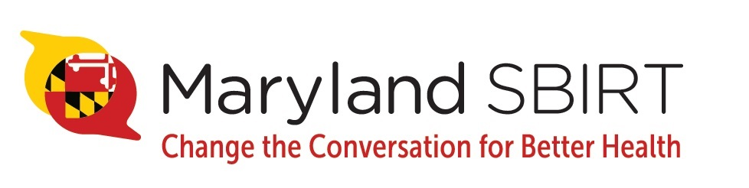

Integrating Primary​Medical Care and Behavioral Health Services

What is SBIRT?
SBIRT (Screening, Brief Intervention, and Referral to Treatment) is an evidence-based, comprehensive, and integrated public health approach to the delivery of early intervention and treatment services to patients who have risky alcohol or drug use.
Through multiple grants provided by the Substance Abuse and Mental Health Services Administration (SAMHSA), the Maryland Behavioral Health Administration has implemented SBIRT into many healthcare settings across the state including over 34 emergency departments, 10 hospital mother-baby units, 22 OB/GYN practices, 7 detention centers, 20 public schools, 4 colleges, and 172 primary care practices. The program has resulted in over 1.3 million screenings, 100,000 brief interventions, and 20,000 referrals to treatment.
Maryland SBIRT aims to address drug overdose deaths, health disparity outcomes among minorities, and healthcare costs in Maryland.
Importance of SBIRT
The problem of alcohol and drug misuse is widespread in Maryland. By initiating a conversation and providing information, health care providers can normalize the conversation and help patients identify risky use early and make choices that lead to better health.
SBIRT can reduce:
- Healthcare costs: Studies show cost savings of $3.81 to $5.60 for every $1.00 invested in SBIRT services.
- Emergency department visits, non-fatal injuries, hospitalizations, arrests, and motor vehicle crashes.
- Severity of drug and alcohol use: Studies show that substance use screening and intervention help people recognize and change unhealthy patterns of use.
- Risk of physical trauma and percentage of patients who go without specialized substance use treatment.
Given SBIRT’s demonstrated cost and health savings, federal agencies such as the Substance Abuse and Mental Health Services Administration (SAMHSA), Veterans Administration, Department of Defense and the White House Office of National Drug Control Policy, as well as managed care providers and major medical associations, have recommended SBIRT’s routine use.

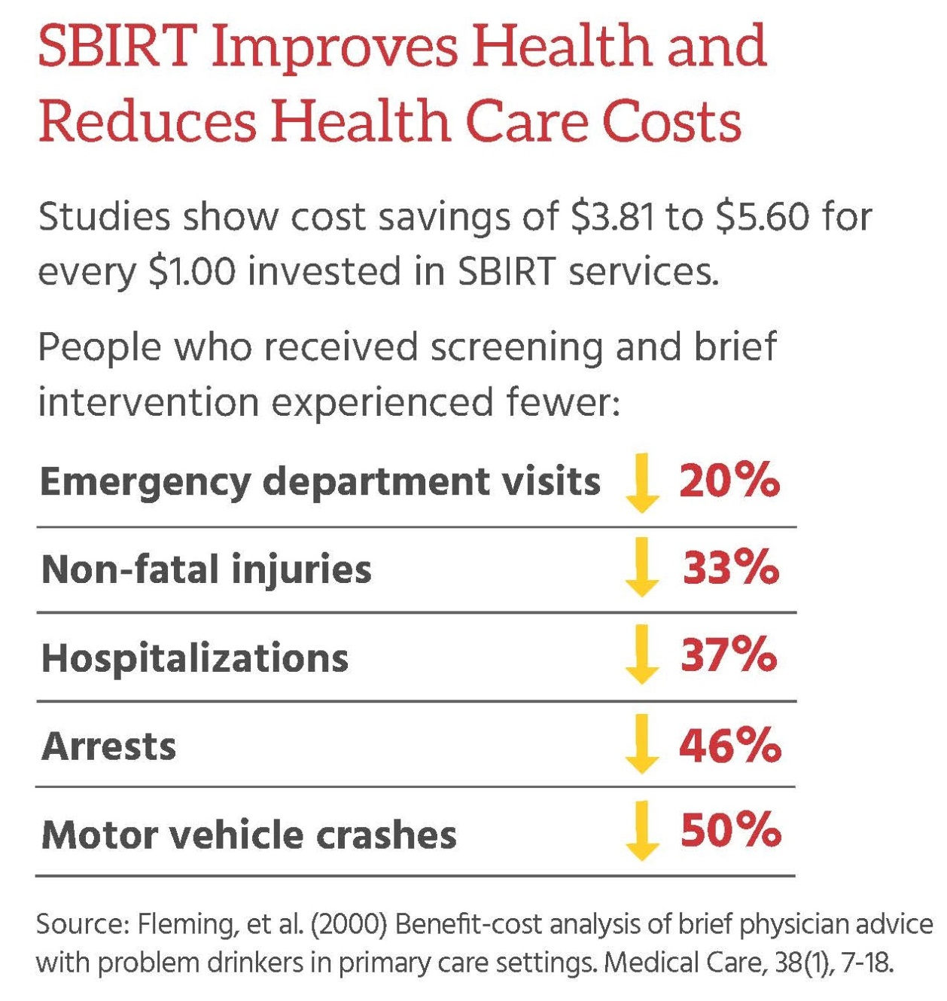
​
Related Links
Professional Training
SBIRT Training for Physicians and Other Health Care Professionals – This 6-video series was produced in 2017. Physician-trainers discuss the rationale and practice of screening all patients for alcohol and drug use by using Screening, Brief Intervention and Referral to Treatment (SBIRT) screening tools and brief intervention techniques, and discuss effective ways to link patients with specialty care for substance use disorders. The 6th video describes Maryland’s Prescription Drug Monitoring Program. Each tape lasts 15 minutes. Continuing education credits are not available when viewing videos on Vimeo. However, CEU’s are available when viewing videos 1-5 on University of Maryland’s behavioral health training website.

- University of Maryland Behavioral Health Training Website (CEU available) - A slightly revised version of SBIRT videos 1-5 and CEU’s from the American Psychological Association are available at: https://mdbehavioralhealth.com/training.

- Links to Vimeo (no CEU, no CME):
https://vimeo.com/230036280 - Introduction to Alcohol and Drug Screening, Brief Intervention and Referral to Treatment (SBIRT) (15 minutes)
https://vimeo.com/235750033 - Screening (15 minutes)
https://vimeo.com/235753849 - Brief Intervention Part 1 (15 minutes)
https://vimeo.com/236933270 - Brief Intervention Part 2 (15 minutes)
https://vimeo.com/236935741 - Referral to Treatment (15 minutes)
https://vimeo.com/230030058 - Maryland Prescription Drug Monitoring Program (15 minutes)

SBIRT Conversations - Below is a link to the new online “SBIRT Conversations” training for physicians and other health care provides. The training was developed by MedChi, the Maryland State Medical Society and Marianne Cloeren, MD. The interactive online SBIRT training offers up to 2.0 CME’s for physicians and certificates of participation for non-physicians. Training is FREE! 2 modules are specific to OB/GYN practice and 2 modules are for pediatric practice settings. https://beacon360.content.online/xbcs/S1511/catalog/product.xhtml?eid=14229

​
For more information on the importance of SBIRT, go to http://www.integration.samsha.gov/sbirt_issue_brief.pdf​
Reimbursement for SBIRT Services
http://www.samhsa.gov/sbirt/coding-reimbursement
If you have any questions about the project, please contact the Maryland Behavioral Health Administration’s Office of Early Intervention & Wellness Services at 410-402-8600.

