Fiscal 2021 Cost Reporting Instructions for Fee Payment Services (FPS) Funded by the Developmental Disabilities Administration (DDA)
Transmittal #: DDA2016019

CO ST REP O RTI NG RE GU LA TO RY R EQ UI R EM EN TS
These cost report requirements apply to services funded by the Developmental Disabilities Administration (“DDA”) under its Fee Payment System for Licensed providers of Residential Services, Day Habilitation Services, Community Learning Services, Supported Employment Services, and Employment Discovery and Customization Services (pursuant to COMAR 10.22.17) and Personal Supports Services (pursuant to COMAR 10.22.18).

As required by the Maryland Annotated Code’s Health-General Article § 7-306.1 and COMAR 10.22.17.05 and 10.22.18.03, providers that receive funding from the DDA for services regulated by the DDA must submit an annual cost report, and required supporting documentation, for each service no later than six months after the end of the State Fiscal Year. The State Fiscal Year ends on June 30th each year and, thus, providers have until December 31st each year to submit their cost reports. Fiscal year 2021 cost reports are due to DDA by December 31, 2021.
The FY 2021 cost report instructions have been updated to accommodate temporary modifications to DDA’s Waiver programs as set forth in Appendix K. The temporary modifications were designed to address the State of Emergency due to the COVID-19 pandemic, beginning March 13, 2020. To support the health, safety, and wellbeing of participants and providers, the DDA implemented temporary service exceptions and operational flexibilities related to financial support, settings, and staffing. To accommodate appendix K a couple of key changes have been made to the cost report.
- First, on the attendance tabs (A-Res, B-Day, B1-CLS, C-SE, C1-EDC, D-PS) the new COVID-19 attendance codes have been added to the PCIS2 Payable Days to be filled in by the provider.
- Second, the instructions for running the attendance report (SECTION 2 ATENDANCE) have been slightly modified to break out the COVID-19 related attendance. Please pay close attention to SECTION 2: ATTENDANCE where specific instructions on generating attendance reports are found.
The cost report must:

- Document the provider’s actual and accrued expenditures and revenue for the fiscal year (July 1, 2020 - June 30, 2021) being reported;
- Be based on the provider’s audited financial statement (prepared on the accrual basis and in accordance with Generally Accepted Accounting Principles (GAAP);
- Includes a worksheet reconciling the cost report to the financial statement; and
- Contain a certification by an independent Certified Public Accountant, who is not an employee of the provider or any affiliated organization, for the individual co-payments that should have been collected from the provider’s clients and for actual attendance days of the provider’s clients.

The law permits the DDA, after notice and an opportunity to request a hearing in writing, to impose a penalty not exceeding $500 per day on providers that fail to comply with the cost reporting requirements. (See Md Code Ann., Health-General Article §7- 910(c); COMAR 10.22.17.05F; and COMAR 10.22.18.03C).

SUB M I SSI O N I NF O RM ATI O N
To comply with cost reporting requirements outlined in the Maryland law and regulations referenced above, providers must submit the following signed documents to DDA:

- Cost Report Data Form (.xls and .pdf)
- Audited Financial Statements on the state’s fiscal year (July 1, 2020 - June 30, 2021) (.pdf)
- Attestation to provider attendance days and the individuals’ payment to room and board and cost of care by an independent CPA. (.pdf)

The DDA Cost Report Data Form must be used. It is located on the DDA website, under the Provider tab DDAFormsforProvider,CostReportandWageSurvey. Do not alter the format in any way and make sure that the 2021 template is used. Submit two copies of the cost report, one in Microsoft Excel format (.xls, xlsx) and one in Adobe Acrobat format (.pdf). The cover page of the cost report must be signed by the provider in the Adobe Acrobat file. If the cost report is prepared by someone other than the provider administrator they must sign the cover page in the designated space beneath the provider administrator’s signature.

For the Audited Financial Statements and Attestations, the accepted electronic format is Adobe Acrobat (.pdf). The attestation letter template must be used, and is located on the DDA website with the cost report template. The Audited Financial Statements and Attestations must be signed by an independent Certified Public Accountant (CPA).

Each provider must submit an annual cost report, and required supporting documentation, for each service no later than six months after the end of the State Fiscal Year. The State Fiscal Year ends on June 30th each year and, thus, providers have until December 31st each year to submit their cost reports. Please electronically submit your fiscal year 2021 cost report to DDA by December 31, 2021 to the following email address: dda.reconciliations@maryland.gov.

ATT ES TA TI O N I NS TR UC TI O NS

An independent Certified Public Accountant (CPA) must attest to a provider’s Client Attendance Days data (the days that the client received the provider’s services) and Client Fees (the co-payment amounts paid by the client to the provider). CPAs must examine the accompanying Statements of Client Attendance Days and Client Fees of a provider for the State Fiscal Year (July 1 – June 30). The Statements of Client Attendance Days and Client Fees are the responsibility of the provider. The responsibility of the CPA is to express an opinion on these statements based on his or her examination. The CPA’s examination should be conducted in accordance with attestation standards by the American
Institute of Certified Public Accountants and the regulations of the State of Maryland Department of Health and, accordingly, include examining, on a test basis, evidence supporting the Statements of Client Attendance Days and Client Fee, and performing such other procedures as considered necessary
in the circumstances.

CLIEN T ATTEN D ANCE DAYS
To verify the accuracy and reliability of the provider's records regarding attendance days, CPAs should complete the following procedures.

- Prepare a summary of the procedures used by the provider for accumulating and identifying attendance days;
- Assure the adequacy of the procedures and documentation used by the provider to accumulate and identify attendance days;
- Examine the provider's attendance days accumulations by tracing total and summary totals to the document of original entry;
- Compare a sample of Maryland Department of Health attendance forms with Client files and medical records that substantiate attendance and absence; and
- Note any attendance discrepancies between the provider's records and the MDH attendance forms.

Based on the CPA’s examination, the CPA must report the number of attendance days by service by quarter.

CLIEN T FEES
To determine that client fees are collected and accounted for in accordance with applicable regulations, CPAs should complete the following procedures.

- Review Maryland Department of Health (“MDH”) and DDA regulations, policies, and guidelines regarding client fees;
- Disclose any deficiencies in internal control regarding (1) the collection of client fees; and (2) the safekeeping of client personal funds;
- Reconcile the client fees collected with the amount reported on client matrix forms;
- Verify client fees collected with source documents and traced to the provider's bank account; and
- Prepare proposed adjustments based on findings.

Based on the CPA’s examination, the CPA must report the totals collected from residential participants for the following types of client fees, separately:

- Cost of care; and
- Room and board costs.

CO ST REP O RT D AT A F O RM I NS TR UC T I O NS

The Cost Report Data Form excel workbook is composed of 13 worksheets, identified by a tab and tab title at the bottom of the workbook. These instructions are organized by the tabs in the Cost Report Data

Form workbook. For each of the 13 worksheets, please enter values into corresponding blank cells that can be selected. The spreadsheets include cells that automatically calculate values, which are identified by a grey coloring.

COV ER SHEE T
The cover sheet serves two purposes:

- To gather basic information necessary for DDA to identify and communicate with your provider; and
- To certify that the report is complete and accurate.

Please ensure that both a contact person and an alternate contact person are listed with their corresponding information – please include extension with telephone number.

SCHED U LES A, B, B1, C, C1, & D: DDA FEE PAYMEN T SYS TEM SERV ICES
Below are general instructions for the following tabs and their corresponding services providers must report on.

- Residential Services (Res)
- Day Services (Day)
B1. Community Learning Services (CLS)
- Supported Employment (SE)
C1. Education Discovery and Customization (EDC)
D. Personal Support Services (PS)

SECTION 1: CLA S SI FIC ATIO N O F OPERATI NG EXPEN SE S

In this section, an agency will detail operating expenses.

COLUMNS

- Direct Support Cost Center
Identify the direct support expenses associated with each line item. These would include direct support professionals’ and certified nursing assistants’ salaries and fringe benefits, as well as food, utilities, rent or building depreciation, supplies, and equipment that relate to the direct support of consumers. Include in this column the salaries of all employees whose responsibilities directly impact the provision of direct support services to consumers (e.g., aide, service worker, first line supervisor, and house manager). Other costs related to the employees identified in this cost center should appear in this column.
- Administrative Cost Center
Identify the administrative expenses associated with each line item. This should reflect all overhead costs, and would include salaries and fringe benefits associated with administrative
positions (e.g., executive director; program directors; assistant program directors; clerical support; fiscal, human services, and other administrative staff), cost of administrative offices, insurance, and supplies. These administrative expenditures support the provision of direct support services to consumers. The allocation of these costs should follow the allocation method used in the provider’s audited financial records.
- Add-on Components
Complete this column for residential, day, community learning services, supported employment, employment discovery & customization, and personal supports, if an add-on component was provided for any of the FPS services. This would include total expenditures reimbursed under add-on components.
- Supplemental Services
Identify the costs associated with the provision of non-FPS supplemental services.
- Totals
  - This column will calculate automatically, based on the information added in the preceding columns.
  - This column represents the sum of the corresponding line item expenses for the Direct Support Cost Center, Administrative Cost Center, Add-on Components, and Supplemental Services columns.

LINE ITEMS
Input values based on the description of expenses in the table. If you cannot find a specific line item that coincides with your records, list the expenditure under the most appropriate or use schedule I “Other Expense” to list the type of expenses and the amounts that support the expenses. Below are definitions for some of the broader expense categories.

- Salaries and Wages
  - General administrative employees
    - Examples include executive director, program directors, assistant program directors, clerical support, fiscal, human resources, and other administrative staff.
  - Direct support employees
    - Examples include aides, service workers, first line supervisors, and house managers.
  - Professional employees
    - Examples include doctors, nurses, certified nursing assistants, psychologists, and psychiatrists.
  - Contractors
    - Include in this section, expenditures for individuals who are not employees of the provider, but independent contractors. This should include such as costs associated with services from temporary employment agencies, and with individuals who are not supervised by your organization. Use the examples listed above as guidelines for determining general, direct support and professional staffing.
- Fringe Benefits
  - Fringe benefits paid for the above-noted employees.
  - This should exclude contractors.

- Transportation
- Include transportation costs associated with transporting clients to all activities, including to and from the program, doctors’ offices, and other activities.
  - Salaries and wages for employees with transportation duties should be reported under the categories contained in the salaries and wages section.

An independent CPA must attest to the client attendance.
SECTION 2: ATTEN DA NCE
Attendance data needs to be reported for each service. Use the actual date the provider began serving each client, not the date services were authorized to begin, to calculate the total number of attendance days per quarter.

- PCIS2 Attendance Reports

Residential, Day, CLS, SE, EDC
- Include the attendance days currently reported in PCIS2 for each type of attendance day. This can be found by clicking on the Reports=> Category: Attendance, Available Reports: Attendance Summary=>Provider=>Service=>Fiscal Year 2021=> Quarter 1, 2, 3, 4.
Personal Supports
- Include the attendance days currently reported in PCIS2 for each type of attendance day. This can be found by clicking on the Reports=> Category: Attendance, Available Reports: Personal Supports Attendance by Quarter=>Provider=>Fiscal Year 2021.

- Provider Attendance Record
  - On the rows labeled “Fee Payment System Payable Days,” include the attendance days reimbursed by FPS or PS
    - The “FPS Payable Days” attendance totals should agree with the payable attendance days certified by the CPA after examination of evidence supporting the attendance days reported in PCIS2.
  - On the rows labeled “FPS Non-Payable Days,” include the attendance days not reimbursed by FPS or PS.
  - On the rows labeled “Non-DDA Attendance,” include, if applicable, the attendance days for individuals in the service but not funded by the DDA.

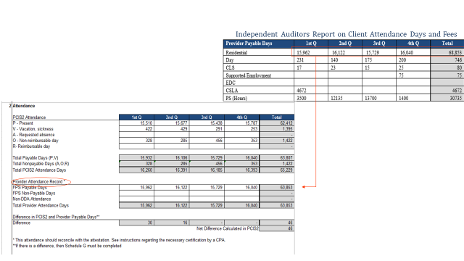

- Difference in PCIS2 and Provider Payable Days
  - Values in this table will populate if the total payable days in PCIS2 does not equal the payable days reported from your provider attendance records.
    - If the values are all equal to zero “–”, then provider records match PCIS2 and no further action is required.
    - If any of the values is not equal to zero, then complete “Schedule G – Attendance Reconciliation” to explain any discrepancy between attendance days as reported in PCIS2 and the provider attendance record. More instructions are provided in section Schedule G of this guide.

SECTION 3: SITE IN FORM AT ION DAT A

This data will provide DDA with general information about provider operations. It is understood
that this data changes frequently. Please report based on the provider’s status as of June 30th for the year being reported.

SCHED U LE E: OTHER EXP ENSES
If the provider or CPA cannot find a specific line item that coincides with the provider’s records, use this schedule to list the type of expenses and the amounts that support the expenses. Schedule E is broken down into six sections: A, B, B1, C, C1, and D. Each section has a table that corresponds to the FPS service schedule and tab. Please place expenses and the amounts in the schedule corresponding to the specific service. The totals of the other expenses will automatically populate in the main classification of expenses in Section 1 of Tabs A, B, B1, C, C1, and D.

SCHEDULE F: NE T OP ERATIN G INCOME (NOI)
This schedule will be used to measure net operating income for DDA services and to reconcile revenues and expenses with your audited financial statements.

SECTION 1: OPERATI N G RE VENUE
- Revenue
  - List Fee Payment System and Fee Payment System revenue under the proper DDA program.
  - Under “Non-DDA Revenue”, include other funds received from third parties and used for services. This would include, but is not limited to, private pay, insurance (excluding DDA-Medicaid payments), funding from other State agencies, or non-profit or grant programs like United Way. For fiscal year 2021 we are asking providers to report any Non-DDA revenue received from other sources in light of the COVID-19 pandemic costs. A specific line has been added on the Schedule F (NOI) tab for this purpose. The designated cell is highlighted in yellow.
  - Applicable only to providers that provide Residential Services:
    - The provider should include the actual collections for room and board payments into the amount under “Non-DDA Revenue.”
      - If a provider requested reimbursement for room and board for a client, then the provider needs to report information on that client on Schedule I.
      - If a provider did not request reimbursement for room and board for a client, then that information does not need to be reported.
    - The provider should list the actual collections from clients’ contribution to cost of care for the residential program. This amount should be certified by a CPA firm. An independent CPA must attest to the client fees.
      - Actual collections should not be confused with expected contributions as reported in PCIS2.
      - Expected contribution is the amount that DDA expects you to collect (as recorded in PCIS2 under the Earned Payment Detail tab), while actual collections is the amount you actually collected.
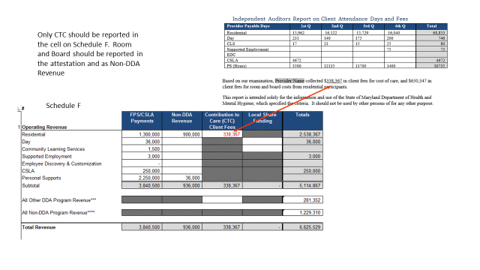
      - If a discrepancy exists between expected Contribution to Care (CTC) and actual receipts please complete “Schedule H - CTC Reconciliation,” to explain each difference.
  - Under “All Other DDA Revenue,” all other revenue funded by the DDA for programs not listed in the cost report, such as Family Support Services (FSS), Individual Support Services (ISS), and Individual Family Care (IFC), should be reported here.
  - Under “All Other Non-DDA Revenue,” include all other revenue for Non-DDA programs.
  - Under “All Other Non-DDA COVID-19 Related Revenue,” include all other revenue for Non-DDA programs.

Total Revenues for FPS attendance based services should reconcile with total revenues on the audited financial statements based on the State’s Fiscal Year July 1, 2020 – June 30, 2021. The provider’s cost report will be considered non-compliant if revenues are not reported on the State’s Fiscal Year.

SECTION 2: OPERATI N G EX PENSE S
- Expenditures
  - Totals from Tabs A, B, B1, C, C1, and D will automatically populate in this table.
  - Under “All Other DDA Operating Expenses,” all other expenses incurred for DDA programs not listed in the cost report, such as FSS, ISS, and IFC, should be reported
here.
  - Under “All DDA Non-Operating Expenses,” enter all non-operating expenses, such as interest expense, pension changes, or swap adjustments, for all DDA programs.
  - Under “All Other Non-DDA Expenses,” include all other expenses for Non-DDA programs.

Total Expenses for FPS attendance based services should reconcile with total expenses on the audited financial statements based on the State’s Fiscal Year July 1, 2020 - June 30, 2021. The provider’s cost report will be considered non-compliant if expenses are not reported on the State’s Fiscal Year.
SECTION 3: NET OPER ATIN G INCOME/ (LOS S) O F DDA SERVICES

This table will automatically calculate the provider’s net operating income for DDA services.

SECTION 4: EXPL AN ATION OF TOTAL REVEN UES/EXPE NSE S ON AUDITED FINA NCI AL STATE MENT S

Use this section only if the total revenue and/or total expenses reported on the cost report do not reconcile with the total revenue and/or total expenses reported in the audited financial statements. If the total revenue/expenses number in the cost report does not equal the total revenue/expenses number in the audited financial statement, but the addition or subtraction of other revenues/expenses does reconcile the numbers, then this calculation needs to be explained in this section. The provider’s cost report will be considered non-compliant if a clear explanation is not provided tying revenues to expenses, potentially subjecting the provider to fines not to exceed $500 per day.

SCHEDULE G: ATTEN D ANCE RE CON CI LI ATIO N
This schedule is used only if there is a variance between payable attendance days reported in PCIS2 and payable attendance days in the provider’s record. If there is no difference between the PCIS2 payable days and the payable days in the provider record, then this section does not need to be completed. To process the reconciliation of the attendance data, an explanation of the variance should be reported here. Attendance is reconciled in days.

If the total of PCIS2 payable days is less than the total of payable days reported in the provider’s attendance records, then the provider will need to explain each difference in attendance to be reimbursed. A provider may not be reimbursed for any differences that are unexplained.
- If the total of PCIS2 payable days is more than the total of payable days reported in the provider’s attendance records, then the provider will also need to explain each difference. The difference in attendance will be recouped by the DDA.
- Error update reports must be submitted during the reconciliation process in order for providers to get paid if attendance record indicate that DDA owes money to a provider.

For columns “Service,” “PCIS2 Attendance Category,” and “Actual Attendance Category,” there is a drop down list in the cell that provides all the categories. The provider can access this list by first
clicking on the cell and then clicking on the down arrow or you can use your keyboard to tab to the cell
and then press the ALT + Down Arrow Cursor buttons. These drop downs are used to correctly report the service and attendance classification.
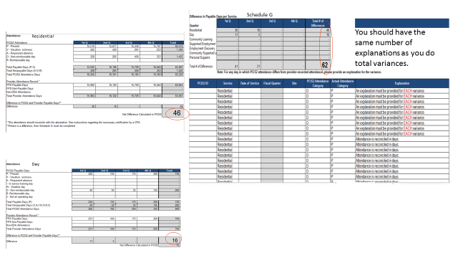
SCHED U LE H: CON TRIB UTIO N TO CARE RECO N CI LI ATION
Providers that provide Residential Services must provide information on Contribution to Cost of Care (CTC). A provider must report the total contribution to care calculated in PCIS2, and individualized information on the collection of those fees.

The annual expected CTC for all clients receiving Residential Services from the provider can be located in PCIS2 by submitting a query under the Payment’s module under the Consumer Payments Details’ tab.

- Choose Earned Payment Details under Report Type
- Choose Residential under Service Type
- Choose your provider under Provider
- Type the fiscal year
- Check the Summarize by Fiscal Year box
- Hit the Submit Query button

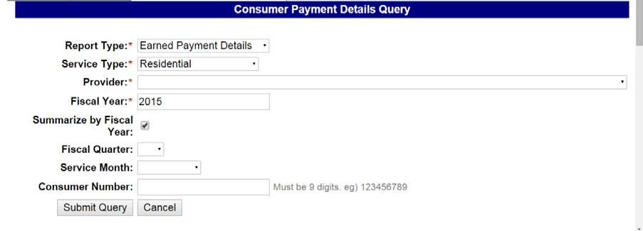
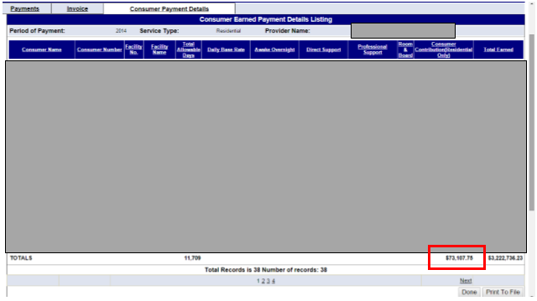

Under the column Consumer Contribution (Residential Only) and the row Totals, is the running total for that fiscal year. Input this number into cell C8, Total Contribution to Care in PCIS2.

You must also report for every client:

  - The client’s annual expected contribution to care (calculated in PCIS2);
  - The annual payment from the individual for cost of care; and
  - The annual payment of CTC invoices from DDA for uncollectible cost of care, if any

As stated in the Contribution to Care guidance, no other formula may be used to calculate cost of care other than what is outlined in DDA’s federal waiver program, which is the formula used in the PCIS2 CTC form. If a provider has reported payments from an individual that exceed the individual’s PCIS2 CTC form, then those funds may only represent corrections to provider errors in the PCIS2 CTC form. If the CTC form is correct and the provider still obtained more collections from the individual, then the
provider should not input that information on Schedule H and must immediately return the excess
funds.

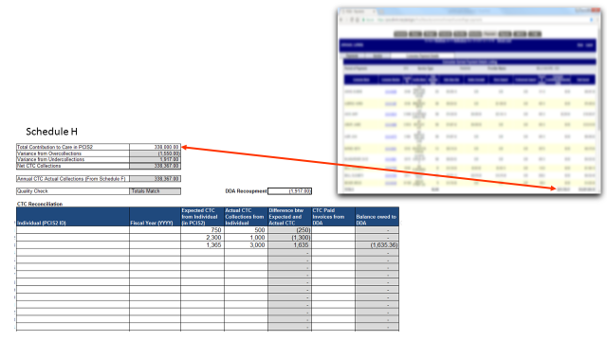

SCHED U LE I: RO OM AN D BO ARD REC ONCI LI ATION

If a provider received payment from room and board invoices from the DDA for uncollectible room and board fees, then the provider must report, on an individual basis, the annual reimbursement from DDA and the total unpaid amount from the client, including what was invoiced to the DDA, as of the end of the State’s Fiscal Year.

SCHED U LE J: WAGE PE RCEN TAGE

Pursuant to § 7-306.3(b) (2) of the Health-General Article of the Maryland Annotated Code, the DDA needs to accurately assess whether:

“The percentage of a community provider’s total reported operating expenses, excluding interest on capital and other capital expenses, that is spent on direct support employee
salaries, wages, and fringe benefits for a fiscal year, as reported to the [Maryland] Department [of Health] by the provider in its fiscal year cost report data form, may not be less than the percentage of the community provider’s total reported operating expenses spent on direct support employee salaries, wages, and fringe benefits for the last fiscal year in which the rate increase for community service providers is less than 3.0% over the funding provided in the legislative appropriation for Community Services in the prior fiscal year.”

The Schedule J will automatically calculate this percentage, based on provider inputs in Tabs A, B, B1, C, C1, and D.

- Total operating expenses is the sum of the grand totals in Tabs A, B, B1, C, C1, and D.
- Direct support expenses is the sum of the total salaries and wages for direct support employees and their total fringe benefits that were provided in Tabs A, B, B1, C, C1, and D.

The direct support expenses over the total operating expenses will calculate the wage percentage that will be used to measure your use of additional funding in future fiscal years in accordance with the statute detailed above.

DD A CO S T REP O RT RE VI EW C RTI ERI A

Each submitted cost report package will be evaluated against the cost report requirements below in order to determine completeness. If any of the answers to the questions below is “No,” then the cost report is considered incomplete. The DDA may impose a penalty not exceeding $500 per day on the provider due to noncompliance in accordance with § 7-910(c) of the Health-General Article of the Maryland Annotated Code.

REQU IRED DOC UMEN TS

- Cost Report submitted? (Y/N)
  - Two points of contact present on page 1 of the Cost Report? (Y/N)
  - Is the report signed by the provider? (Y/N)
  - Is report submitted in both Microsoft Excel and Adobe Acrobat? (Y/N)
- Audited Financial Statement submitted? (Y/N)
  - Is the statement signed by the auditor? (Y/N)
- Attestation of Attendance Days and Client Fees submitted? (Y/N)
  - Is the statement signed by the auditor? (Y/N)
  - Is attendance data provided in the Attestation? (Y/N)
  - Is client fee data for cost of care provided in the Attestation? (Y/N/NA)

RECO NCI LI ATI ON
- Do the amounts for “Total Expenses” and “Total Revenues” in Schedule F: Net Operating Income of the Cost Report agree with the Audited Financial Statement? (Y/N)

ATTEND AN CE RECORD
- Is attendance data provided in the Cost Report? (Y/N)
- Does the attendance data in the Cost Report agree with the attendance data in the Attestation? (Y/N)
- Does the PCIS2 attendance data reported in the Cost Report agree with the attendance data in PCIS2? (Y/N)
- If provider attendance data and PCIS2 attendance data do not agree is Schedule G completed? (Y/N/NA)

CLIEN T FEES
- Is client fee data for cost of care provided in the Cost Report? (Y/N/NA)
- Do the client fees for cost of care in the Cost Report agree with the client fees in the Attestation? (Y/N/NA)
- Does the PCIS2 cost of care data reported in the Cost Report agree with the cost of care data in PCIS2? (Y/N/NA)
- If provider collected contribution to care, is Schedule H completed and do the “Totals Match”? (Y/N/NA)
- If provider received reimbursement from DDA for room and board, is Schedule I completed? (Y/N/NA)

LTSS SERVICES
An independent audited financial statement is required for providers billing in LTSS as well. The only requirement for providers billing in LTSS is to report DDA related revenue and expenditures as a separate line item on the audited financial statement.

TRAINING AND SUPPORT

The FY 2021 cost report instructions have been altered to accommodate appendix K in light of the COVID-19 pandemic. Training will be provided upon request. Please email Ron Peele at: ronald.peele@maryland.gov if you have any questions about how to fill out the cost report or would like to schedule training.

