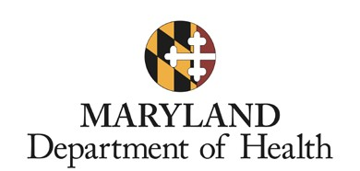

Developmental Disability Administration (DDA) Supports and Services Planning Tool

Person’s Name: Date of Interview:

Initial Date of Planning Tool:
Date of DDA Referral: Date of Initial Contact:
Region (Check one) CMRO ESRO SMRO WMRO

Address:
County:
Phone: |  | Email:

Assigned Coordinator of Community Services (CCS)
CCS Name/Agency: /

- Circle of Support (Authorized representative, family, friends, people who know you best)

Who are the critical members of your circle of support? Are they present?
Name | Relationship | Contact Information | Present? (Y/N)

- Identify Goals and Preferences
Everyone wants a good life. What does a good life mean to you? Help identify what you do and don’t want. For example, for many people, a good life includes living in their own home, having friends and family in their lives, working, and more. We will use this information to help plan for life experiences, supports, and services that point you in the direction of your good life.

Vision for a Good Life
What do you want?
Describe how you want your overall good life to look: | Perspective of your Circle of Support (if applicable):
What don’t you want?
Describe what you don’t want in your life: | Perspective of your Circle of Support (if applicable):

- Identify Strengths

What do people like and admire about you? What are your talents, strengths, and skills?

- Guided Conversation on Employment and Daily Life

- Are you currently working or have you worked in the past? If you aren't currently working, are you interested in working? If not, why not?

- If engaged in volunteer work or other similar activity, would you like to consider a job where you could do similar types of activities?

- Is there anything that you believe challenges your ability to do the things you like or are interested in during the day?

- Integrated Services and Supports Star

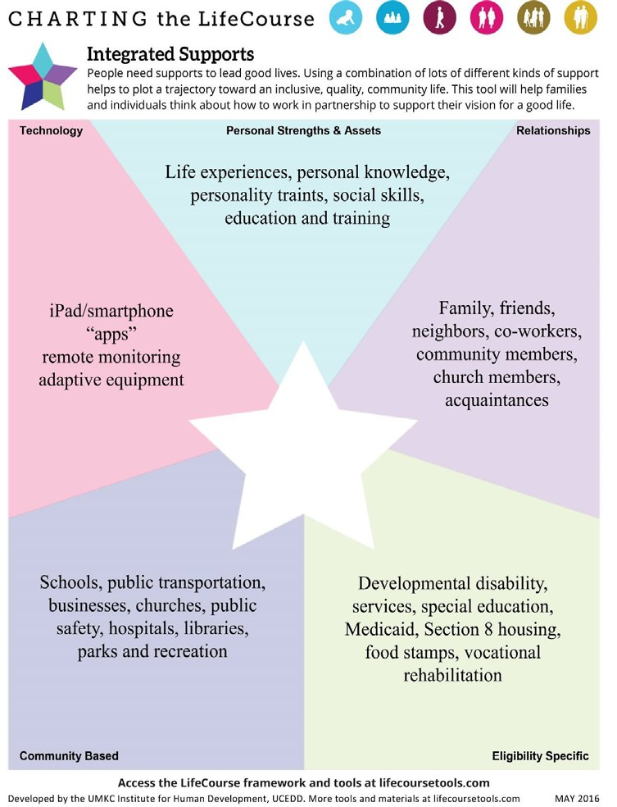
All people need supports to lead good lives. Using a combination of lots of different kinds of support helps people have an inclusive, quality, community life. This tool helps people think about how to work in partnership to support your vision for a good life. Use your responses to the tool to address questions on the following page.

- Personal strengths and assets:

- Relationship-based supports:

- Technology:

- Community-based supports:

- Eligibility-specific supports:

- Perceived Services and Support Needs

Your perspective:
What’s Working? | What’s Not Working?

Perspective of your Circle of Support:
What’s Working? | What’s Not Working?

- Accessible Public Service Needs

Your CCS is able to help you connect with needed public services such as those offered by the Behavioral Health Administration (BHA) and Division of Rehabilitation Services (DORS). Which do you need currently?

- Summary of Service Needs

What are your current support and service needs?
What do you need?  Describe the specific current need. | What community resources are you using now? What should currently be explored? | Are there relevant DDA waiver services available to address your current need?

Provide a detailed description of need for any Meaningful Day, Support Services, or Residential Services using the chart on the next page.

DDA WAIVER SERVICES REQUESTED TO SUPPORT OUTCOMES
Use the list of services below to reference available DDA waiver services for the table on the previous page.
MEANINGFUL DAYS SERVICES
 | Supported Employment |  | Career Exploration |  | Day Habilitation
 | Employment Discovery and Customization |  | Community Development Services |  | Medical Day Care
SUPPORT SERVICES
 | Assistive Technology and Services |  | Individual and Family-Directed Goods and Services |  | Personal Supports
 | Behavioral Support Services |  | Housing Support Services |  | Remote Support Services
 | Environmental Assessment |  | Live-In Caregiver Supports |  | Respite Care Services
 | Environmental Modification |  | Nurse Consultation |  | Support Broker Services
 | Family and Peer Mentoring |  | Nurse Health Case Management |  | Transition Services
 | Family Caregiver Training and Empowerment Services |  | Nurse Case Management and Delegation |  | Transportation
 | Participant Education, Training and Advocacy Supports |  |  |  | Vehicle Modification
RESIDENTIAL SERVICES
 | Community Living/Group Home |  | Shared Living |  | Supported Living (effective July 1, 2019)

- Acknowledgement/Consent

By signing this assessment, I acknowledge that my CCS has thoroughly explained that completion of the tool does not guarantee enrollment into any waiver. At any point, if my service needs change while on the DDA Waiting List, I will reach out to my CCS to meet and update this tool.
I have been informed that if selected to apply for waiver services, my CCS will assist me in completing the DDA application.

Person –or– Authorized Representative Signature Date

Coordinator of Community Services Signature Date

