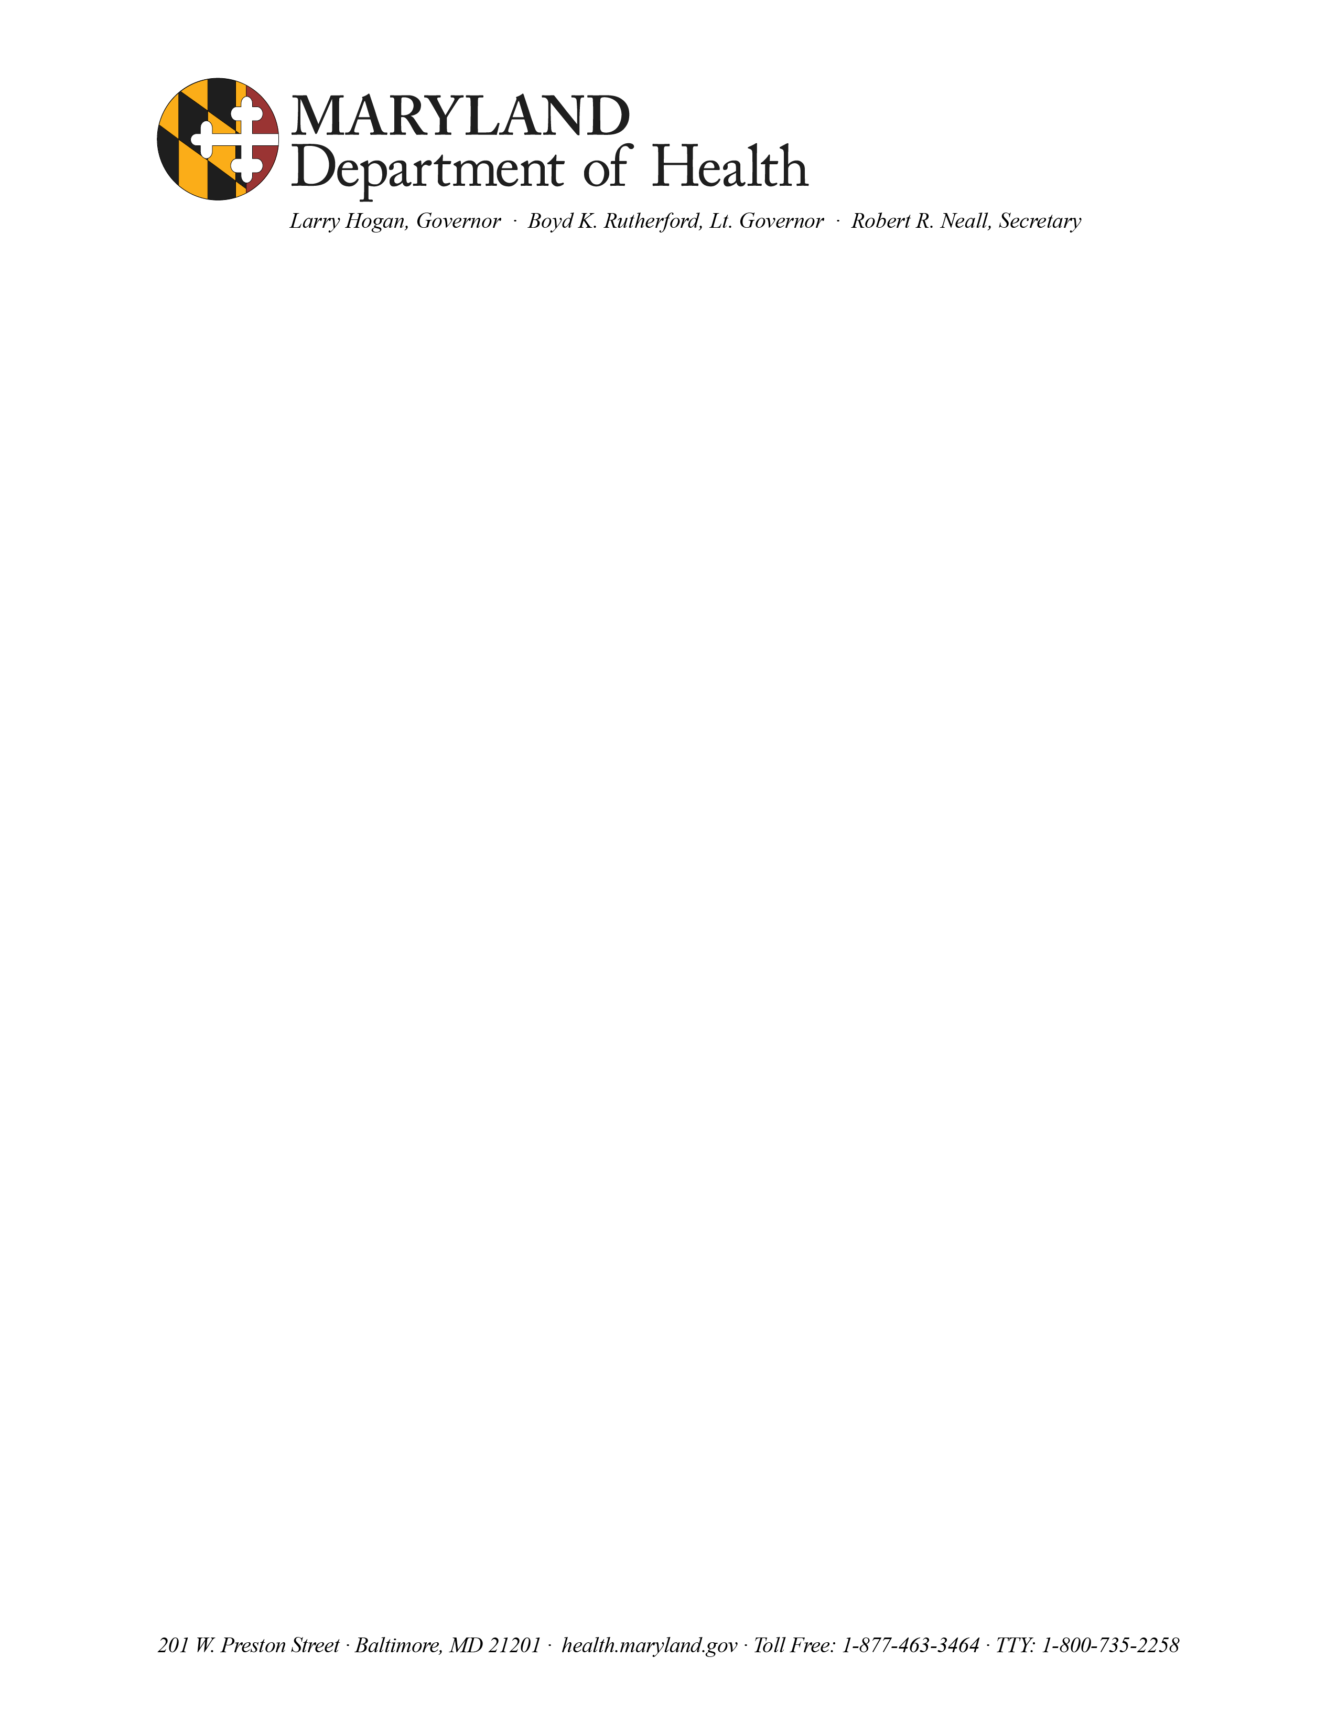

Certified Receipt of Position Description (MS-22)

I hereby acknowledge receipt of the position description for the vacancy of

in the
CLASSIFICATION PROGRAM

NAME/DATE

WITNESS

