Sftp Client Instructions (WinSCP in this example)

STEP ONE: DOWNLOADING AND INSTALLING SFTP CLIENT
- Download WinSCP at https://winscp.net/eng/download.php
- Save the file and open to install.

STEP TWO: CONFIGURATION

After installing the client, open the client and enter the credentials given to you. To save these details for future use, click save. To start connection, click Login.

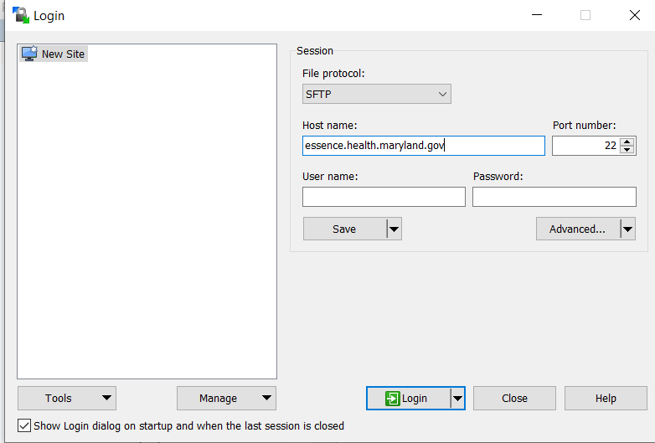

The first login will prompt you to download the SSH key. Accept the key and afterwards, you can log into the server successfully using an automated or manual method

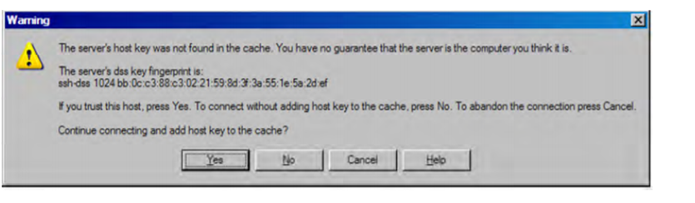
STEP THREE: UPLOADING DATA

- An example of what the interface should look like when you connect
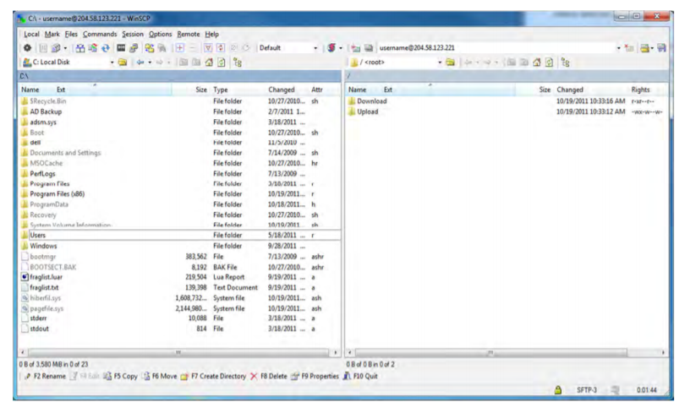
- Click on the file you would like to upload. Click upload. Press OK.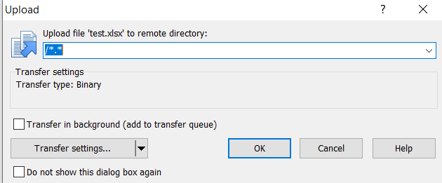
- You will see the file appear on the right side.
- Click on the X to exit WinSCP.

