Appendix A: Rapid POC Test Algorithm
Centers for Disease Control Antigen Test Algorithm*
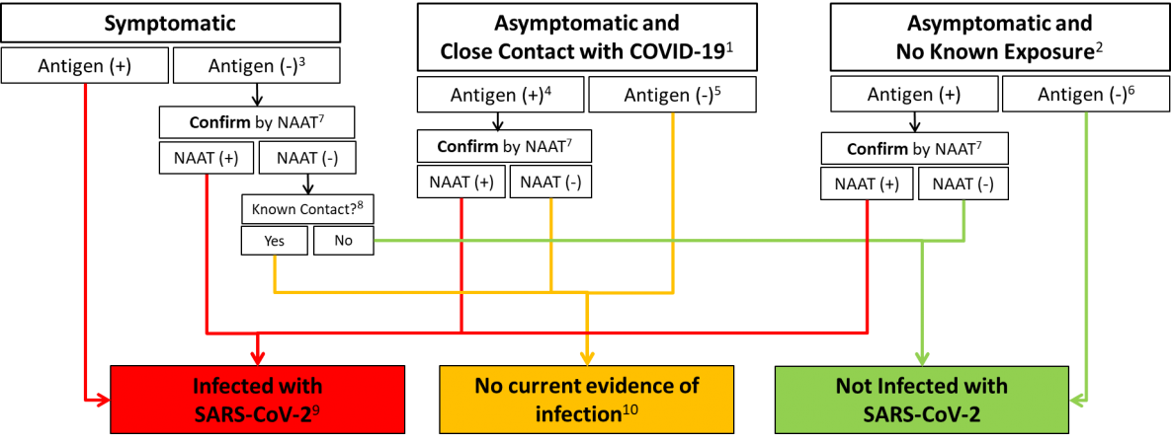
(Last updated December 5, 2020)
*NAAT=nucleic acid amplification test, a molecular test used to detect the presence of viral nucleic acid.
Source: https://www.cdc.gov/coronavirus/2019-ncov/images/lab/figure1-antigen-test-algorithm-large.png
- Single, multiple, or continuous known exposure to a person with COVID-19 within the last 14 days; perform NAAT first if short turnaround time is available, if person cannot be effectively and safely quarantined, or if there are barriers to possible confirmatory testing
- No known exposure to a person with COVID-19 within the last 14 days
- If a symptomatic person has a low likelihood of SARS-CoV-2 infection, clinical discretion should determine if this negative antigen test result requires confirmatory testing
- In instances of higher pretest probability, such as high incidence of incidence of infection in the community, clinical discretion should determine if this positive antigen result requires confirmation
- In certain settings, serial antigen testing could be considered for those with a negative antigen test result; serial testing may not require confirmation of negative results
- If prevalence of infection is not low in the community, clinical discretion should consider whether this negative antigen result requires confirmation
- Nucleic acid amplification test; confirm within 48 hours using a NAAT, such as RT-PCR, that has been evaluated against FDA’s reference panel for analytical sensitivity
- Known exposure to a person with COVID-19 within the last 14 days; if unsure, clinical discretion should determine whether isolation is necessary
- Isolation is necessary for at least 10 days since symptom onset or positive test result, and at least 24 hours with no fever without fever-reducing medication 10Infection control measures are necessary for 14 days after last known exposure to a person with COVID-19; clinical discretion should determine if and when additional testing is necessary

Appendix B: Sample Testing Verification Form
[Insert Health Department or Agency Letterhead]

Name of Individual Tested: _______________________________________________________

Test Date: _____________________________Test Time: ______________________________

The above individual was tested for COVID-19 at _____________________________________
Testing Site

If you received a PCR diagnostic test, your test results will be available within approximately two to seven days, depending on laboratory testing demands and resources. Due to the high volume of tests being processed across the country, it may take longer than expected to receive your results. While awaiting test results, patients should remain at home and avoid contact with others.

If you received a rapid point-of-care (POC) test, your test results would have been made available to you within 15-20 minutes while you remained on site.
For more information on COVID-19 and how individuals can protect themselves and others, please visit https://coronavirus.maryland.gov.

Verified by: ____________________________________________________________________
Testing site manager

Appendix C: Sample Results Log for Multiple Tests

Facility Name: Dr. Jones’ Medical Facility
Location: 123 Main Street, Town, MD 22222
Date | Sample # | Patient Name or ID | Test Name | Reportable Range | Test Result | Lot Number | Exp. Date | Initials
1/1/20 | 123456 | John Doe | BinaxNOW |  | NEG | BN-1234 | 7/1/20 | AB

Appendix D: Sample Results Log with Quality Control

Facility Name: Dr. Jones’ Medical Facility
Location: 123 Main Street, Town, MD 22222 Test Name: ____BinaxNOW___
Date | Patient ID | Test Result | Initials | Lot Number & Exp. | QC Lots & Exp. | POS Control Results | NEG Control Results
1/1/20 | Jane Doe | NEG | AB | BN-1234  7/1/20 | 123-BQ  4/1/20 | POS | NEG
Appendix E: Bulk Submission of Rapid POC Results

Entities that are conducting at least 20 POC tests a day may submit their results to CRISP via a bulk submission process. Step-by-step instructions and the corresponding documentation needed to do this are included in this appendix as follows:

General Information
- Each organization may submit one file per day.
- It is critical that the submitter select the correct test machine and specimen.
  - If your test machine is not listed, please contact support@crisphealth.org.
- All columns in the spreadsheet are required.
File Requirements
- File must be named: YYYMMDD_NPI.csv
  - If you have multiple NPIs in your spreadsheet, simply pick one of them to include in the filename.
- File must be saved as .csv
  - In Microsoft Excel, click File → Save As → CSV (Comma delimited) (*.csv).
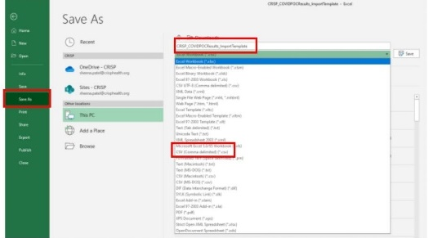

Submission Process
- Log into your CRISP Direct email account.
  - If you do not have a Direct account, please contact your CRISP Outreach Representative or email support@crisphealth.org. Please specify that you are requesting a CRISP Direct account for POC reporting purposes.
- Send an email to pocreporting@crispdirect.org, with your daily file attached.
Corresponding Documentation
- POC Bulk Submission Template
  - Use this template to prepare your submission. Do not delete or alter any columns or column/headers.
- Machine – Specimen Type spreadsheet
  - Use this spreadsheet to ensure you are picking from the correct Specimen Type options for your particular machine.

