
Dress in Blue Day
Wear Blue to Raise Awareness about Colon Cancer Screening

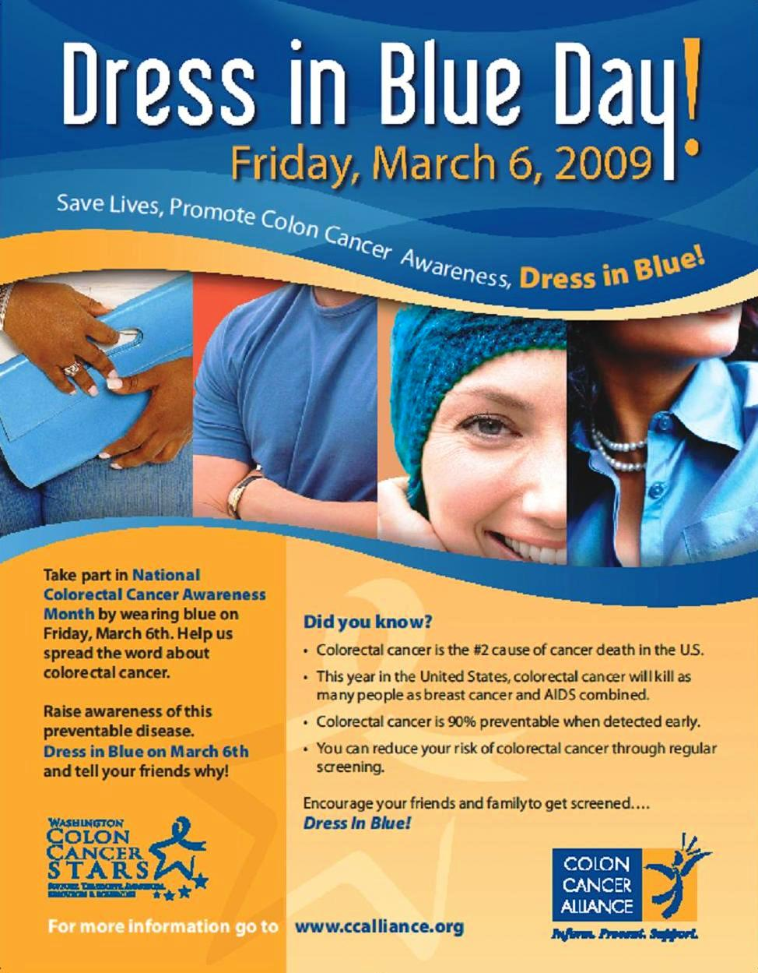
WASHINGTON, D.C. (January 21, 2009) – The 1st Annual National Dress In Blue Day event will be held in communities and offices nationwide on Friday, March 6th as part of Colon Cancer Awareness Month.

“The purpose of Dress in Blue Day is to promote awareness about colorectal cancer and encourage people to get screened,” said Andrew Spiegel, CEO of the Colon Cancer Alliance (CCA). “Colon cancer is the second leading cause of cancer related deaths in the country and we need to make sure that everyone over 50 is talking with their doctor about getting screened. Dress in Blue Day is our way of getting people to talk about this important issue and save lives in the process.”

Dress in Blue Day takes place on the first Friday in March and encourages individuals, businesses and community groups to wear blue and talk to each other about the importance of colon cancer screenings. In addition to asking people to Dress in Blue, CCA is providing individuals with “Ask Me Why I’m in Blue” stickers designed to prompt meaningful and lifesaving conversations about this highly preventable disease.

March 2009 will mark the 10th Annual “National Colorectal Cancer Awareness Month.” Colon cancer is the second leading cause of cancer related deaths in the United States, killing as many people as breast cancer and AIDS combined, but when caught and diagnosed early, it can be treated quickly and effectively.

The idea for Dress in Blue Day originated in 2006 when a CCA volunteer and co-founder of Colon S.T.A.R.S. of Seattle wanted to find an effective way to honor a friend who had recently passed away from colon cancer and recognize others who had lost their fight against colorectal cancer. In 2009, the CCA, excited by the idea, worked with the group to bring national recognition to the Dress in Blue Day.

The CCA is the nation’s leading colorectal cancer organization, focused on meeting individual patient and caregiver needs by connecting each of those diagnosed with a support network through its Online Colorectal Cancer Community, Buddy Program and Toll-Free Help line. The CCA is working to get people talking about their colon’s health and to promote early screenings through education and fun events such as the Undy 5000 (www.undy5000.org), 5K run walks that take place across the county; regional seminars; and the annual Dress in Blue Day.
# # #

The Colon Cancer Alliance (CCA) is a national patient advocacy organization dedicated to ending the suffering caused by colorectal cancer. In order to increase rates of screening and survivorship, CCA provides patient support, education, research and advocacy across North America.

As the Voice of Survivors, CCA works as an advocate for colorectal cancer patients and their families. CCA offers information and support from the first-hand experience of survivors and others whose lives have been touched by this disease.

Today, CCA has over 37,000 members. Our help line receives an average of 700 calls monthly, and our support networks have assisted over 150,000 people. The growth and success of the organization is due in large part to caring volunteers who devote considerable time, skill and energy to achieving CCA's vision.

