Maryland Department of Health and Mental Hygiene
Family Health Administration
Center for Cancer Surveillance and Control
CRF/CPEST Database Access Request

Create Account Delete Account Modify Account Reactivate Account

Database access requested:

Client Database (CDB) Education Database (EDB) CDB/GIS Mapper

Please Print or Edit in Microsoft Word
First Name | MI | Last Name

Address Street |  | Room
City | State | Zip Code
Jurisdiction |  | Phone Number
Program |  | E-Mail
Network Administrator Name |  | Phone Number
Connected to DHMH Network Yes No

Instructions:
1. Complete all information.
2. Review the following policies:
DHMH Electronic Information System Policy 02.01.01 -- http://www.dhmh.state.md.us/policies/020101.pdf
DHMH Software Policy 02.01.02 -- http://www.dhmh.state.md.us/policies/p020102.htm
DHMH Information Assurance Policy 02.01.06 -- http://www.dhmh.state.md.us/policies/summary.htm
3. Using blue ink, provide original signatures on this Database Access Request Form, the Confidentiality Agreement, and the DHMH Combined IRMA Policy Acknowledgement Form.
4: Mail these three forms to: Maryland Department of Health and Mental Hygiene
Center for Cancer Surveillance and Control
201 West Preston Street, SEU, Room 406A
Baltimore, MD. 21201

Signature of User ___________________________________________ Date _______________

Signature of User’s Supervisor ________________________________ Date _______________

For Client Database (CDB) only: Access Role^ (check one) | Check Box
Data Manager
Data Enterer
Case Manager
Analyst
Reports User
^see page 2 for access role definitions for Client Database

_______________________________________________________________________________
For FHA – CCSC Office use only Local State

Approved by __________________________________ Date: __________________

Center for Cancer Surveillance and Control
Cancer Client Database (CDB)

Levels of Access Role Definitions

Name of Access Role | Definition/Description of Features  The individual with this role will have access to do the following functions:
Data Manager* | see identifiers⁺ (data and client-level reports)  add/update data  print labels/letters  download data file with identifiers⁺
Data Enterer* | see identifiers⁺ (data and client-level reports)  add/update data  print labels/letters
Data Enterer* | no download data
Case Manager* | see identifiers⁺ (data and reports) )  print labels/letters
Case Manager* | no add/update data  no download data
Analyst | see data and reports without identifiers  download data file without identifiers
Analyst | no print labels/letters  no add/update data
Reports User | see reports without identifiers
Reports User | no add/update data  no print labels/letters  no download data

*Role implies access to confidential data: Your Program and personnel must follow HIPAA, State law, and local policies/procedures to protect data
⁺Identifiers include information (such as name, address, and date of birth) attached to the client’s confidential medical information

State of Maryland
Department of Health and Mental Hygiene
Center for Cancer Surveillance and Control (CCSC)
Client Database (CDB)

CONFIDENTIALITY AGREEMENT

I, , understand that as part of the Cigarette Restitution Fund (CRF) Program, Cancer Prevention, Education, Screening and Treatment (CPEST) Program, I will be working with confidential information contained in the Client Database (CDB). I also understand that the confidentiality of this information is established by Md. Code Ann., Health-General §§4-101 to 4-103 and that a person who uses or discloses this information is in violation of these statutes and is subject to the legal penalties set forth therein.

I understand that I am responsible for protecting the confidentiality of information pertaining to individuals receiving cancer services as contained in the CDB, including but not limited to a person’s address and/or other identifying information and medical information. I agree to keep this information confidential.

I also understand that this information may be used only for purposes directly related to the CRF/CPEST Program and that no person who is not engaged in this specific program may have access to this information.

I understand that the CDB shall not be used in a public place or on a public computer and shall be accessed at a worksite approved by the user’s supervisor, and I agree to comply with the CPEST CDB Policy.

Acknowledgement and Signature
I have read and understand the above Confidentiality Agreement and agree to treat confidential information accordingly.

____________________________
Signature

____________________________
Name Typed or Printed

_____________________________
Title

____________________________
Institution or Organization

____________________________
Date
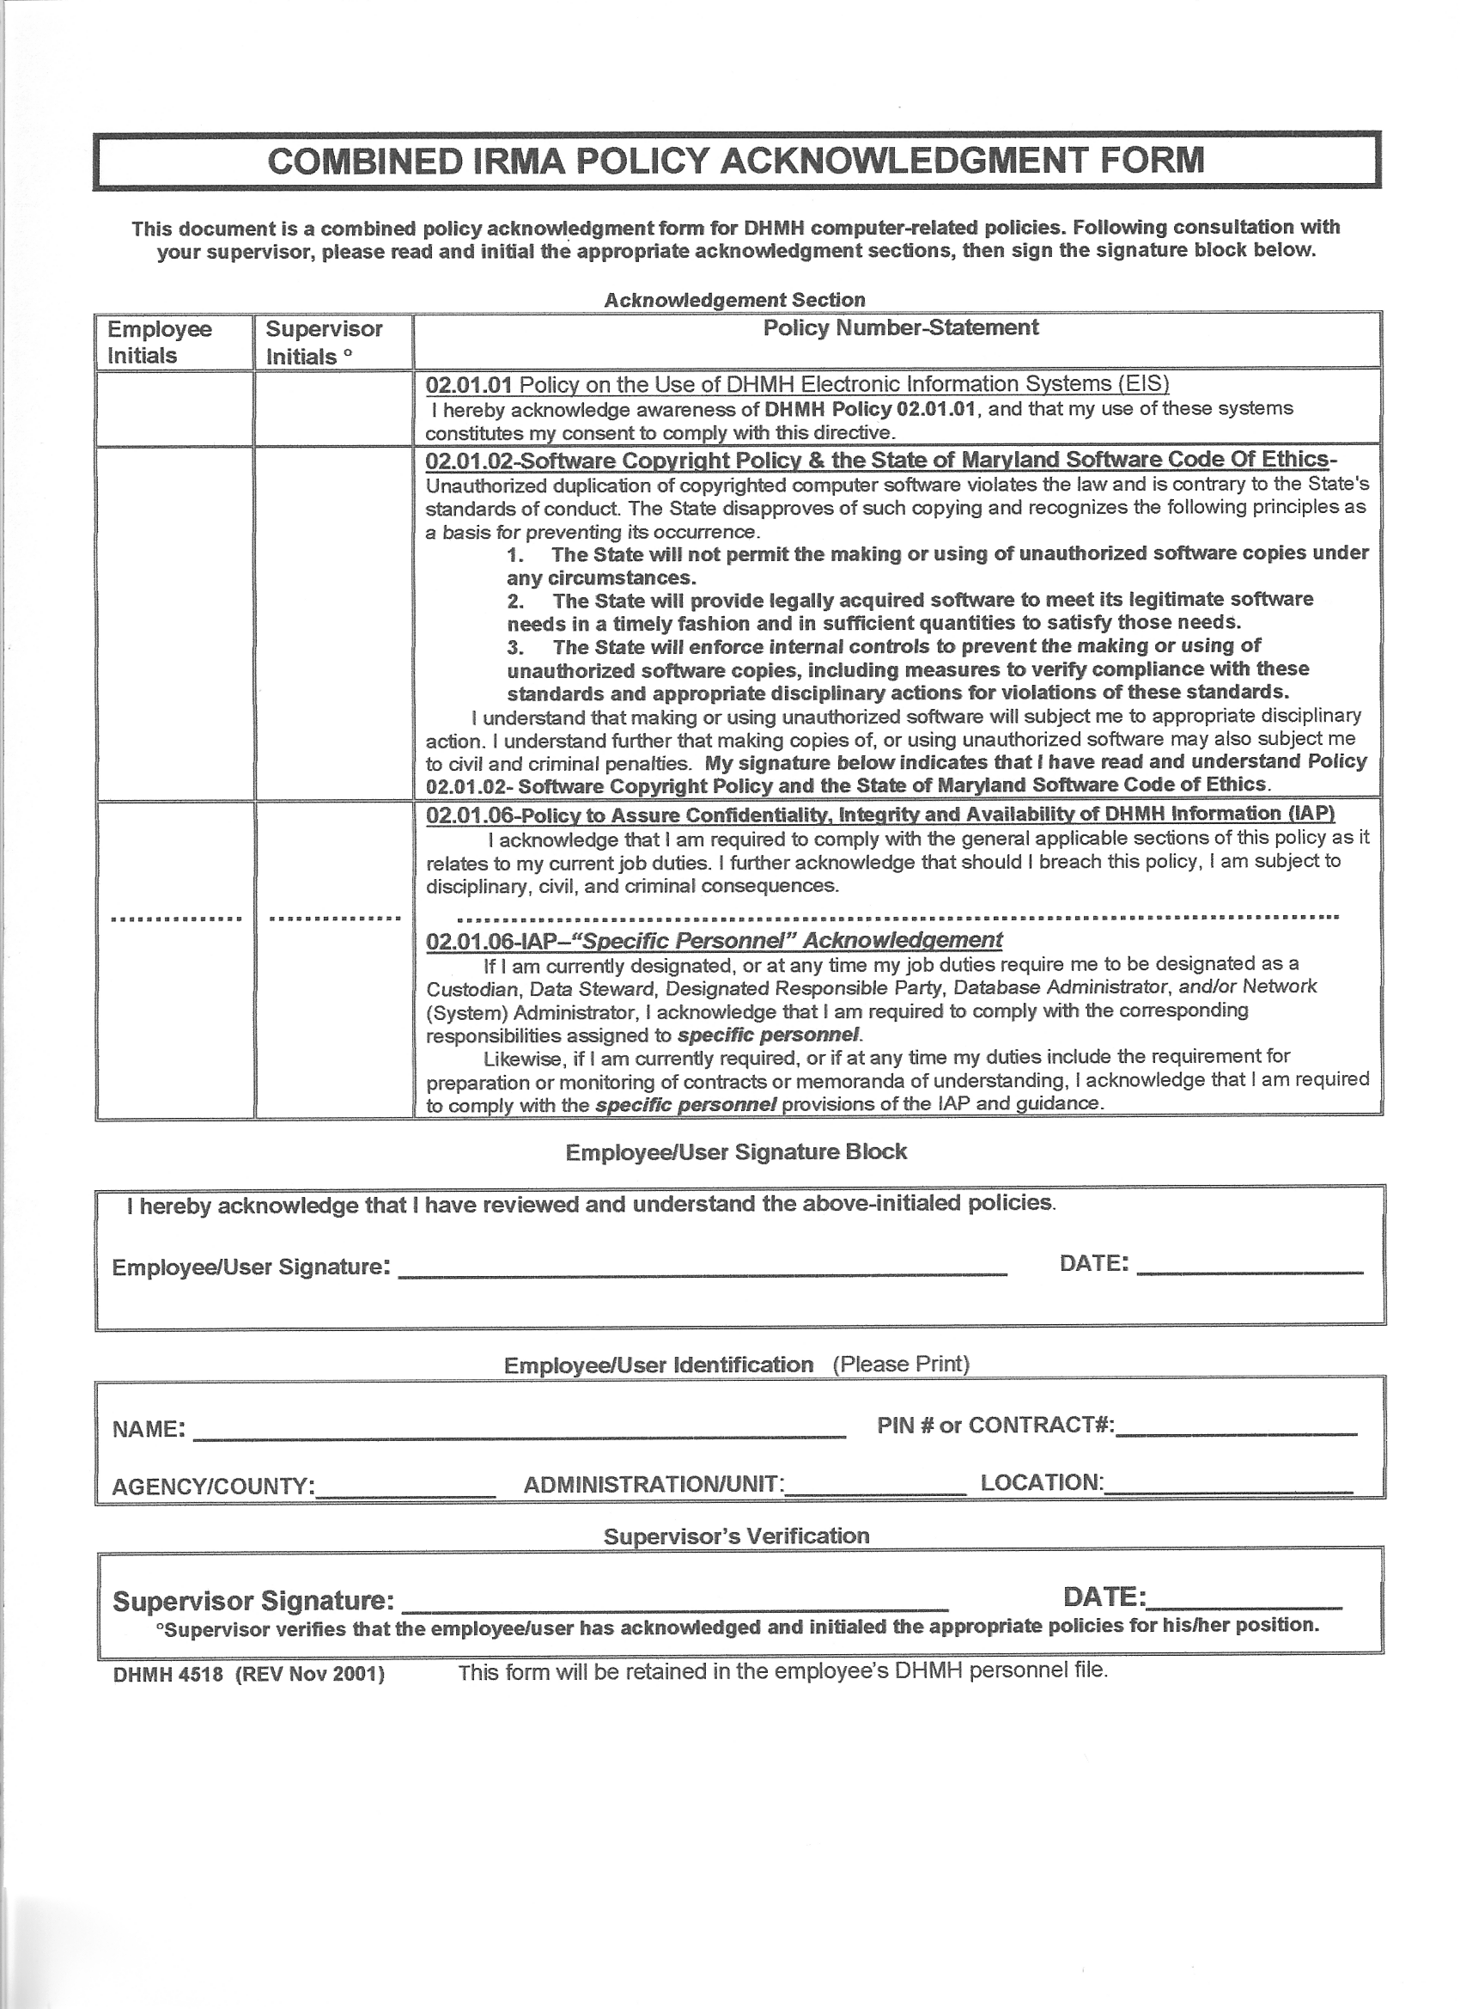
http://www.dhmh.state.md.us/policies/op02.htm , or see Page 1, above, for links to the policies

