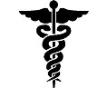
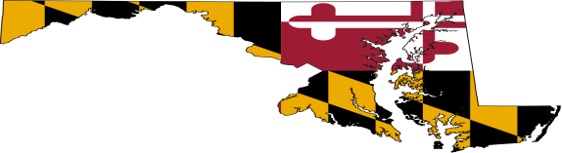
Maryland Primary Care Office
The Maryland Primary Care Office (PCO) is federally funded by the Health Resources and Services Administration’s Bureau of Health Workforce (BHW) to promote federal, state, local, and private collaboration to expand comprehensive, community based primary care services for medically underserved populations. This is achieved by addressing five grant Program Expectations:

- Organizational Effectiveness/Fostering Collaboration
- Technical Assistance to Organizations/Communities Wishing to Expand Access to Primary Care for Underserved Populations
- Assessment of Needs/Sharing of Data
- Workforce Development for the NHSC and Safety Net/Health Center Network
- Shortage Designation Applications and Update

Grant Programs
PCO administers one federally funded grant from the Health Resources and Services Administration (HRSA):

Primary Care Office Grant: The purpose of this five year grant is to manage or influence access to primary care services through the development of systems of care for the underserved by achieving the five program expectations listed above. The PCO’s work is directly linked to the mission of HRSA and its Bureau of Health Workforce (BHW).

For more information contact:
Elizabeth Vaidya
Director, Primary Care Office
Telephone: 410-767-5695
Fax: 410-333-7501
Email: Elizabeth.vaidya@maryland.gov
Website: http://phpa.dhmh.maryland.gov/opca/Pages/pco-home.aspx

