DDA Inpatient Facilities

Rhonda Callum, Director John Hancock, Data Program Manager

RESIDENT GRIEVANCE SYSTEM
Maryland Department of Health Office of the Deputy Secretary of Behavioral Health Fiscal Year 2020
Table of Contents

PART I – RESIDENT GRIEVANCE SYSTEM
Background & Structure of Patients’ Rights Program 3
Resident Grievance System 3
Legal Assistance Providers 4
CLASSIFICATION OF RIGHTS
Grievances 6
Stage One 6
Stage Two 7
Stage Three 7
Stage Four 7
Information and Assistance 8
Rights Categories 8
Annual Data 12

PART II – FACILITY DATA
Section A: Grievance Data 13
Aggregate DDA Facilities 13
Holly Center 15
Potomac Center 17
Secured Evaluation Therapeutic Treatment 19
Section B: Information and Assistance Data 21
Aggregate DDA Facilities 21
Holly Center 23
Potomac Center 25
Secured Evaluation Therapeutic Treatment 27

PART I

RESIDENT GRIEVANCE SYSTEM
Developmental Disabilities Administration (DDA)
State Residential Centers
and the
Secured Evaluation Therapeutic Treatment Unit (SETT)
Fiscal Year 2020

Background & Structure of the Resident Grievance System

The Resident Grievance System was established in 1985 as part of a negotiated settlement of the class-action lawsuit, Coe v Hughes, et al. The negotiated settlement, titled the Coe Consent Decree, created a two-tiered advocacy program to enforce rights guaranteed by federal and state laws and regulations; to assist patients with claims for benefits and entitlements; to achieve deinstitutionalization; and to assist patients in resolving civil legal problems. The program is governed by the Code of Maryland Regulations (COMAR) 10.21.14, entitled Resident Grievance System, adopted March 28, 1994, and amended January 26, 1998.

The Resident Grievance System is under the auspices of the Deputy Secretary for Behavioral Health within the Maryland Department of Health (MDH). At inception, the program provided services for residents of the seven Behavioral Health Administration’s (BHA)’s Psychiatric Inpatient Facilities.

On July 1, 2000, by order of the Secretary of MDH, RGS expanded to provide rights advocacy for residents of the State Residential Centers (SRCs), operated by the Developmental Disabilities Administration (DDA). The policy governing the operation of the RGS in DDA facilities was finalized and distributed to the facilities by the Director of DDA on December 19, 2002. The policy outlines the procedures governing the administrative process for receiving and investigating, in a timely manner, reports of injuries, deaths, physical, sexual or verbal abuse, and any other rights issues, in accordance with Health-General §7-1003 (g), Annotated Code of Maryland.

In January 2009, RGS began to provide services to the two Secured Evaluation and Therapeutic Treatment (SETT’S) Units operated by DDA. In November 2016, the two units merged into one SETT unit, located on the grounds of Springfield Hospital Center and in 2019 the SETT unit moved to the grounds of Potomac Center in Hagerstown, MD . The mission of the SETT unit is to provide evaluations, assessments, and treatment to court-involved, intellectually disabled individuals, within a secure and safe environment.

Resident Grievance System
The first tier of Maryland’s patient rights program is the Resident Grievance System (RGS). The RGS is a four-stage administrative grievance procedure designed to protect the rights of patients in the BHA and DDA facilities and to provide a timely, fair, efficient, and complete mechanism for receiving, investigating, and resolving residents’ complaints. The central function of the RGS is the resolution of grievances through mediation, negotiation, or conciliation while representing the best interest of the patients. It is designed to be non-adversarial and to ensure that both clinical and legal considerations are properly balanced.

RGS collaboratively works with the Office of Health Care Quality, Disabilities Rights Maryland (DRM) and other stakeholders to ensure patient safety and the protection of their legal rights. RAs are responsible for investigating and mediating allegations of rights violations and providing patient rights education to residents and staff in DDA SRC facilities and SETT Unit. They also help protect the civil rights (voting, confidentiality, etc.) of patients. RAs have satellite offices at each facility. This allows them to attend and participate in various committees and facility meetings, to address patients’ concerns without delay, and to advocate for patients’ rights. To ensure patient services are not interrupted for any reason, all RAs are trained to provide RGS services within any of the SRC and SETT unit.

In January 1996, the RGS implemented toll-free telephone access. This service allows residents to have immediate contact with the RGS and has enhanced the ability to respond rapidly to patient concerns. Referrals to the RGS can be made directly to the assigned RA or the Central Office by using the toll-free number, 1-800-747-7454. During FY 20, RGS received a total of 51 calls via the toll-free number. Graph 1 details the number of calls received per month during FY 20 from the DDA facilities.

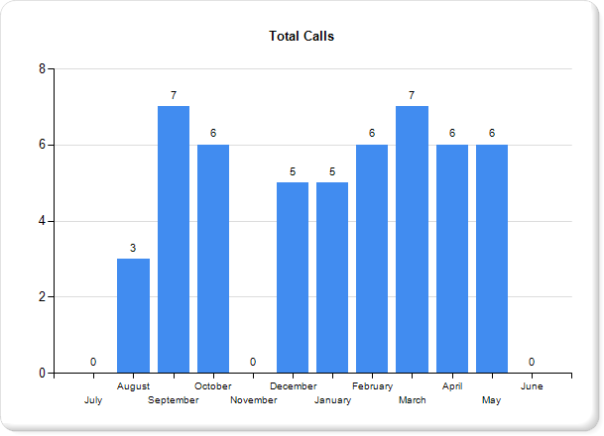
Graph 1 represents the total calls received from the toll-free number by month from residents residing in the SRCs and SETT Unit for FY 2020.

Legal Assistance Providers
Legal Assistance Providers (LAPs) are the second tier of the patient rights program. LAPs are a group of independent attorneys, contracted by RGS, to provide the following specific legal assistance and representation to residents within DDA facilities pursuant to Annotated Code of Maryland, Health General §7-503:

- Admission Hearings – LAPs provide representation on behalf of individuals proposed for admission to a State Residential Center (SRC). In Fiscal Year 2020, LAPs spent 21.6 hours representing individuals at 4 admission hearings. HG §7-503 requires a showing – by clear and convincing evidence – that the conclusions leading to the decision to admit an individual are supported by the following findings:

- The individual has mental retardation;

- The individual needs residential services for the individual’s adequate habilitation; and

- There is no less restrictive setting in which the needed services can be provided that is available to the individual, or will be available to the individual within a reasonable time after the hearing.

- Annual Reviews – LAPs provide representation for residents at an annual review of their current status, to determine whether they continue to meet retention criteria. In Fiscal Year 2020, LAPs spent 96.4 hours conducting 70 re-evaluation reviews. All 70 LAP re-evaluations were in agreement with the State Residential Center (SRC) re-evaluations. HG §7-505 requires a determination of the following:

- Whether this individual continues to meet the requirements of this subtitle for admission to an SRC;

- Whether the services which the individual requires can be provided in a less restrictive setting;

- Whether the individual’s plan of habilitation, as required by §7-1006 of this title, is adequate and suitable; and

- Whether the SRC has complied with and executed, the individual’s plan of habilitation in accordance with the rules, regulations, and standards that the Secretary adopts.

- Habeas Corpus / Petition for Release - LAPs provide representation for residents who request to apply for a Writ of Habeas Corpus or petition for release. There were no residents who requested to apply for a Writ of Habeas Corpus or petition for release in FY 2020.

- §7-506 Habeas Corpus - Any individual who has been admitted to an SRC, or any person on behalf of the individual, may apply at any time to a court of competent jurisdiction for a writ of habeas corpus to determine the cause and the legality of the detention.

- §7-507 Petition for Release - Subject to the limitations in this section, a petition for the release of an individual who is held under this subtitle from an SRC may be filed, at any time, by the individual or any person who has a legitimate interest in the welfare of the individual.

- Transfer Hearings - LAPs provide representation for residents at transfer hearings. In Fiscal Year 2020, the LAP spent 5 hours representing one individual at a transfer hearing at the SETT Unit. Below are the requirements for resident transfers:

- §7-801 Authority of Director - The Director may transfer an individual with a developmental disability from a public residential program or a public day program to another public residential program or public day program, or if a private provider of services agrees to that private program. Such transfers are permitted if the Director finds that the individual with developmental disabilities can (1) receive better treatment in, or would be more likely to benefit from, treatment at the other program; or (2) the safety or welfare of other individuals with developmental disabilities would be furthered.

- §7-802 Transfer to a Mental Health Program - DDA may ask BHA to accept primary responsibility for a resident in an SRC, or an individual eligible for admission to an SRC if DDA finds that the individual would be provided for more appropriately in a program for individuals with mental disorders. BHA shall determine whether it would be appropriate to transfer the individual to a mental health program.

- A dispute over a transfer of an individual from DDA to BHA shall be resolved in accordance with procedures that the Secretary sets, on request of DDA or BHA. The Director shall give the individual with a developmental disability the opportunity for a hearing on the proposed transfer.

CLASSIFICATION OF RIGHTS

- Grievances
A “Grievance” is defined as a written or oral statement which alleges either A) that an individual’s rights have been unfairly limited, violated, or are likely to be violated in the immediate future, or B) that the facility has acted in an illegal or improper manner with respect to an individual, or a group of individuals. Grievances can be initiated by the individual, an employee of the facility, a family member of the individual, a guardian of the individual or an interested party.

Grievance management, a major responsibility of the RA, includes receipt, investigation, and resolution of complaints, as well as compliance with the systematic and orderly four-stage grievance process. At each stage, grievances are determined to be Valid, Invalid, or Inconclusive. A grievance is Valid when evidence is sufficient to prove an allegation. When there is insufficient evidence to prove an allegation, a grievance is Invalid. A grievance is Inconclusive when sufficient evidence does not exist to prove or disprove an allegation. The four stages of the grievance process are described below:

Stage One -- This is the beginning of the four-stage grievance process. During Stage One, the RA receives a complaint from a resident or an individual filing the grievance on behalf of the resident. Once received, the RA determines an appropriate course of action for investigating the grievance, which may include (1) interviewing everyone involved; or (2) requesting documents, statements and correspondence related to the grievance. The RA has 10 working days from receipt of a grievance to gather information, complete an investigation and render a decision. The resident, or the individual filing the grievance on behalf of the resident, is informed of the decision and the right to appeal to the next stage. RAs make every effort to negotiate, mediate and work toward the achievement of a mutually satisfactory resolution at Stage One.
Stage Two -- If unresolved at Stage One, a grievance proceeds to Stage Two for review, investigation, and recommendations by the Unit Director. The unit director shall (1) review the RA’s report; (2) discuss the matter with all involved individuals; and (3) within five working days of receipt of the report, render a written decision regarding the grievance and return it to the RA. The RA informs the grievant of the Stage Two decision and their right to appeal to Stage Three.

Stage Three - If unresolved at Stage Two, the grievance proceeds to Stage Three for review, corrective action if applicable, and/or recommendations by the Chief Executive Officer (CEO), with an optional review by the Resident’s Rights Committee (RRC). Stage Three is divided into two stages – Stage 3A and Stage 3B.
- Stage 3A - The grievant has a right to request a review by the RRC at Stage 3A, prior to the 3B review by the facility’s CEO. If the grievant requests a review by the RRC, the Committee will meet within 15 working days of receipt of the grievance, to review the RA’s report and the unit director’s decision. At this stage, the grievant has the right to attend and present information to the Committee, and to be represented by the LAP. Once all relevant reports and information presented are reviewed, the RRC will forward written recommendations to the CEO.
- Stage 3B – Upon receipt of the grievance, the CEO will review all information from the previous stages. If the CEO finds the grievance to be Valid, the CEO will document in the report, the corrective action to be taken to remedy the violation against the resident. If the CEO finds the grievance Invalid, the decision is forwarded to the RA. The resident is informed of the decision and the right to appeal to Stage Four. The CEO may find the grievance Inconclusive and recommend the grievance is forwarded to Stage Four for a decision by the Central Review Committee.

Stage Four -- Unresolved Stage Three grievances are referred to Stage Four, where they are reviewed by the Central Review Committee (CRC). A CRC appeal is the last and final appeal level of the RGS. An RA is required to make every effort to negotiate, mediate, and resolve the grievance during earlier stages of the RGS. However, the ultimate decision to resolve or appeal the grievance belongs to the patient or the individual submitting the grievance on behalf of the patient. If the patient elects to appeal, the RA is required to assist the patient in filing the appeal, even though the RA may not believe that the request has merit.

The CRC is composed of two members: Director of the RGS and the DDA Director of Quality Enhancement or their designees. The Committee reviews all prior information and recommendations concerning the grievance and may request additional documents or records from the facility, prior to rendering a decision. At the conclusion of the review, the Committee issues a written decision to the facility based on its findings and makes recommendations for corrective action, if warranted. The RGS Director is responsible for monitoring the implementation of all corrective action recommended by the Committee. Residents are notified in writing of the Stage Four decision and the RA provides the patients with additional community resources in the event they are still not satisfied with the Stage Four decision.

The RA has oversight of the grievance process, ensuring that the four stages are completed within 65 working days, as required by COMAR 10.21.14.

In Fiscal Year 2020, RAs processed a total of 71 grievances. Of those 71 grievances, 29 (41%) were resolved at Stage 1, 21 (30%) were resolved at Stage 2, 20 (28%) were resolved at Stage 3 and 1 (1%) was resolved at Stage 4.

Information/Assistance
Cases classified as Information/Assistance do not allege a rights violation but are contacts in which a patient is seeking information, clarification, or assistance with a concern. In Fiscal Year 2020, RAs provided Information and assistance to 578 residents, 89% of the total 649 patient contacts.
The following chart lists the totals of two of the three major classifications (grievances and IA cases) for each of the three DDA inpatient facilities. DDA residents are not forced to take medication. Consequently, CRPs are not held in DDA facilities. Effective November 16, 2016, the two DDA Secure Evaluation Therapeutic Treatment (SETT) Units merged into one SETT unit, located on the grounds of Springfield Hospital Center and in 2019, the SETT unit moved to the grounds of Potomac Center in Hagerstown, MD.

AGGREGATE MAJOR CLASSIFICATIONS BY FACILITY
Facility | Grievances | Information  Assistance | Facility Totals
Holly Center | 10 | 34 | 44
Potomac Center | 31 | 337 | 368
SETT | 30 | 207 | 237
Activity Total | 71 | 578 | 649

- Rights Categories
All patients are entitled to certain rights guaranteed by, and explained in, Health-General Article of Maryland’s Annotated Code, 10-701 to 10-713. The sixteen major categories have been developed to uniformly identify and assign patient complaints to the stipulated rights of patients in Health-General Article Annotated Code of Maryland. Based on patients’ rights guaranteed by Federal and State constitutions, statutes, regulations, common law, or policies of the Department, Behavioral Health Administration, and the facility, the sixteen major rights categories have been identified below and are subject to any reasonable limitation that a facility or guardian may impose.

- Abuse – Patients have the right to be protected from physical, mental or verbal harm. Abuse is defined as cruel or inhumane treatment or an intentional act that causes injury or trauma to another person. Physical abuse is an intentional act that causes injury or trauma by physical, bodily contact, such as hitting, grabbing, shoving, punching or kicking. Sexual abuse is an intentional, unwanted, forced sexual act or threat used to take advantage of an individual not able to give consent, such as unwanted touching, forced sex, or sexually suggestive language. Mental abuse is an intentional act that causes emotional injury or trauma resulting in a diminished sense of self-worth, dignity or identity, such as yelling, swearing, name-calling, insults, threats, intimidation, humiliation, or bullying.

- Admission / Discharge / Transfer:
- Admission - Upon admission, patients have a right to receive information which describes the patient’s admission status, the availability of legal services, the right to talk to a lawyer of choice and their rights while in the hospital. The person has a right to ask questions concerning their admission status and should be provided that opportunity.
- Discharge - The hospital must discharge any patient not committed by the court who is not mentally ill. If committed involuntarily, the treatment team determines when an individual’s condition has stabilized sufficiently for that person to return to the community. Court-appointed patients must receive approval from the judge prior to discharge.

- Transfer – The hospital may transfer patients to another State facility if (1) the patient can benefit from or receive better care or treatment at another facility; or (2) if it is for the protection, safety or welfare of others. However, the patient has a right to be notified of the transfer and have a hearing held prior to the transfer UNLESS an emergency situation exists. In the event of an emergency transfer, the patient has a right to a hearing within 10 days after the transfer.

- Civil Rights – Patients have the same basic rights as all citizens in society. Patients may not be deprived of any civil right such as the right to vote, to receive, hold, and dispose of property, or to practice the religion or faith of choice.

- Communication / Visits - Patients have the right to send and receive mail, have reasonable use of the telephone and receive visitors during reasonable visiting hours that are set by the facility.

- Confidentiality – Patients have the right to have their medical records and information kept confidential and the right to review their medical record upon request, within a reasonable timeframe.

- Environmental – Patients have the right to live with dignity in a safe, clean and sanitary facility. Environmental rights include the right to bath and have personal hygiene needs to be met, to have clean clothes and bed linens, and to have nutritious meals provided daily.

- Freedom of Movement – Patient’s personal liberty can only be restricted based on treatment needs and applicable legal requirements. They have the right to be free from restraint or seclusion except when used during an emergency in which the behavior of the patient places the patient or others at serious threat of violence or injury. The restraint or seclusion must be ordered by a physician, in writing, or directed by a registered nurse if a physician’s order is obtained within 2 hours of the action. Patients have the right to voluntarily request the use of the Quiet Room.

- Money – Patients have the right to a bank account, to have the facility hold money for safekeeping and to access their funds when requested. Patients also have a right to apply for State and federal entitlements and benefits.

- Neglect – The definition of neglect is the failure to properly attend to the needs and care of a patient. Patients have the right to have staff attentive to their needs and to be taken care of with dignity and respect.
- Personal Property – Patients have the right to a reasonable amount of personal property that is not considered contraband or a danger to the patient or others. Patients have a right to receive and store personal property in secure containers and applicable storage units provided by the facility to prevent theft, loss or destruction of their property.

- Rights Protection System – Patients have a right to complain and to get assistance to resolve complaints. The RGS is responsible for ensuring that the rights of patients in BHA and DDA facilities are fully protected and allegations of rights violations are investigated and resolved in a timely manner.

- Treatment Rights – Patients have the right to participate in their treatment and the development and periodic updating of their treatment plans. They have the right to be told in an appropriate and understandable language:

- The content and objectives of the plan;

- The nature and significant possible adverse effects of recommended treatments;

- Information concerning alternative treatment or mental health services that are available, when appropriate;

- The right to have a family member or an advocate, participate in treatment team meetings; and

- The right to refuse medication used for the treatment of a mental disorder except in an emergency, when there is a present danger to life or safety of the patient or others; or in a non-emergency, when involuntarily committed or court-ordered for treatment by the court, and the medication is approved by a CRP.

- Other Rights – Patients have the right to seek assistance, either from a LAP or private attorney, for legal issues outside the jurisdiction of the RGS.

- Resident to Resident Assault – A patient who is assaulted by another patient has the right to press charges against the other patient. RAs do not investigate the incident unless the assault occurred as a result of the staff’s’ neglect. RAs inform all victims that they have one year and a day to report in person to the police department and press formal charges.

- Death - All deaths in a State-funded or operated program or facility, are required to be reported immediately to law enforcement within the jurisdiction in which the death occurred, to the Secretary of MDH, the Health Officer in the jurisdiction where the death occurred, the Office of Health Care Quality, the designated State protection and advocacy agency and the Director of RGS.

- No Rights Involved –. This category is for cases that do not involve a rights violation.

Depending on the alleged rights violation, grievances and IAs can be assigned to anyone of the major sixteen rights categories. Listed below in charts A-B are the number of grievances and IA cases for each DDA facility that fell into each of the sixteen rights categories described above.
Chart A – FY 2020 Grievances
Rights Category | Holly Center | Potomac Center | SETT Springfield
Abuse | 3 | 9 | 8
Admission / Discharge / Transfer | 0 | 0 | 0
Civil Rights | 0 | 5 | 6
Communication / Visits | 0 | 1 | 1
Confidentiality | 0 | 2 | 1
Environmental | 0 | 2 | 6
Freedom of Movement | 0 | 2 | 1
Money | 0 | 0 | 0
Neglect | 7 | 6 | 1
Personal Property | 0 | 1 | 0
Rights Protection System – RGS | 0 | 0 | 0
Treatment Rights | 0 | 3 | 6
Other | 0 | 0 | 0
No Rights Involved | 0 | 0 | 0
Resident to Resident Assault | 0 | 0 | 0
Death | 0 | 0 | 0
TOTAL | 10 | 31 | 30
Chart A lists the total grievances assigned to each of the 16 rights categories for each DDA facility.

Chart B – FY 2020 Information/Assistance
Rights Category | Holly Center | Potomac Center | SETT Springfield
Abuse | 0 | 1 | 1
Admission / Discharge / Transfer | 1 | 8 | 5
Civil Rights | 0 | 0 | 3
Communication / Visits | 0 | 0 | 3
Confidentiality | 0 | 1 | 0
Environmental | 0 | 12 | 28
Freedom of Movement | 0 | 3 | 1
Money | 0 | 0 | 1
Neglect | 0 | 3 | 0
Personal Property | 0 | 2 | 1
Rights Protection System – RGS | 0 | 0 | 3
Treatment Rights | 29 | 9 | 32
Other | 0 | 1 | 1
No Rights Involved | 0 | 3 | 7
Resident to Resident Assault | 3 | 294 | 121
Death | 1 | 0 | 0
TOTAL | 34 | 337 | 207
Chart B lists the total IA cases assigned to each of the 16 rights categories for each DDA facility.

ANNUAL DATA – GRIEVANCES AND IA CASES

Chart C below depicts the total grievances and IA cases for all three DDA facilities combined. As stated earlier, DDA residents are not forced to take medication and as a result, CRPs are not held in DDA facilities. Consequently, only grievances and IA cases are reported. The total number of grievances and IA cases are input into the RGS database for each facility by the RA(s) assigned to that facility. In turn, the information is collected and aggregate totals are calculated by combining individual facility totals. However, current year data alone cannot provide any information regarding trends or discrepancies in the data from year to year. Observing data over time can determine whether an actual change has occurred. Comparing data within and between the two major classifications across a five-year span can point out significant increases or decreases, reveal significant patterns, and point out significant changes. The data in the chart below provides information regarding annual total cases for the two major classifications - grievances and IAs – across five years (2016-2020).

Annual Data 2016 - 2020
Year | 2016 | 2017 | 2018 | 2019 | 2020
Grievances | 8 | 61 | 71 | 82 | 71
IAs | 808 | 334 | 327 | 342 | 578
Totals | 816 | 395 | 398 | 424 | 649
Chart C: FY 17 reflects the beginning of a significant increase in the number of grievances
and a significant decrease in IA cases compared to the previous year. Information
Assistance remains the largest number of patient contacts.

PART II: FACILITY DATA – FY 2020

This section provides facility data for each of the three DDA facilities for the two major types of patient interactions – grievances and IAs. The major interactions are, in turn, reported by data and percentages within three demographic categories - gender, age group, and race. The numbers and percentages for each category are listed in a chart, followed by a set of graphs. The first chart in each section reports aggregate information for all DDA facilities combined. Data for the individual facilities are then listed. The charts and graphs provide valuable information regarding the “number” and “type” of complaints received and the demographic profile of the patients initiating the cases, specific to each facility.

In each section, the category “Race” lists several specific sub-categories – African American, Caucasian, Asian, Hispanic and Native American. Also listed are the sub-categories – Other, Unknown and Class. “Other” represents information collected from residents who selected this category as their gender and/or race. “Unknown” represents information collected from residents who chose not to identify gender and/or race. “Class” represents a class-action grievance or IA case initiated by a group of residents who cannot be assigned to any gender, age group, or race.

Section A reports grievance data by gender, age group and race. The first chart and set of graphs list the total grievances and percentages by category for all three DDA facilities. Following the aggregate DDA grievance data, each individual facility has a chart and set of graphs that list that facility’s grievances by gender, age group, and race.

Section B reports IA data by gender, age group and race. Aggregate DDA IA information is provided for all three facilities, followed by IA numbers for each individual DDA facility.

SECTION A: GRIEVANCE DATA - FY 2020

Developmental Disabilities Administration (DDA)

Aggregate Grievance Cases by Gender, Age Group, and Race
Gender | # | % | AGE | # | % | RACE | # | %
Male | 39 | 54.93 | <18 | 0 | 0 | African  American | 33 | 46.48
Female | 26 | 36.62 | 18-44 | 49 | 69.02 | Caucasian | 27 | 38.03
 |  |  | 45-64 | 12 | 16.9 | Asian | 0 | 0
 |  |  | 65+ | 5 | 7.04 | Hispanic | 0 | 0
 |  |  |  |  |  | Native  American | 0 | 0
Other | 1 | 1.41 | Other | 0 | 0 | Other | 2 | 2.82
Unknown | 0 | 0 | Unknown | 0 | 0 | Unknown | 4 | 5.63
Class | 5 | 7.04 | Class | 5 | 7.04 | Class | 5 | 7.04
Total | 71 | 100 | Total | 71 | 100 | Total | 71 | 100
Chart 1: During FY 20, there were a total of 71 grievances for the two DDA Residential Centers and the Secure Evaluation and Therapeutic Treatment (SETT) Unit.

Other = information collected from residents who selected this category as their gender and/or race.
Unknown = information collected from residents who chose not to identify gender and/or race.
Class = a grievance initiated by a group of residents who cannot be assigned to any gender, age group or race.

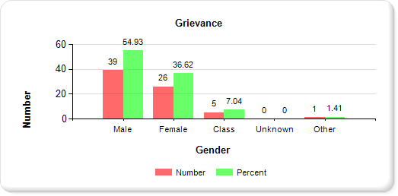
Graph 1A: DDA aggregate grievance data (t = 71) by gender.
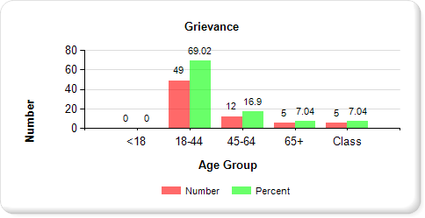
Graph 1B: DDA aggregate grievance data (t = 71) by age.

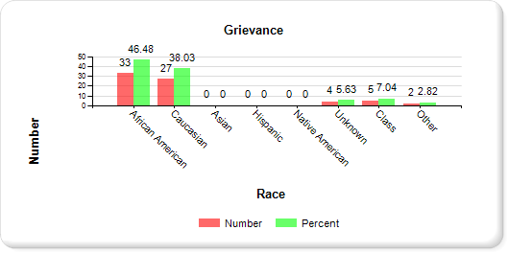
Graph 1C: DDA aggregate grievance data (t = 71) by race.

Holly Center

Grievance Cases by Gender, Age Group, and Race
SEX | # | % | AGE | # | % | RACE | # | %
Male | 5 | 50 | <18 | 0 | 0 | African  American | 3 | 30
Female | 3 | 30 | 18-44 | 1 | 10 | Caucasian | 5 | 50
 |  |  | 45-64 | 2 | 20 | Asian | 0 | 0
 |  |  | 65+ | 5 | 50 | Hispanic | 0 | 0
 |  |  |  |  |  | Native  American | 0 | 0
Other | 0 | 0 | Other | 0 | 0 | Other | 0 | 0
Unknown | 0 | 0 | Unknown | 0 | 0 | Unknown | 0 | 0
Class | 2 | 20 | Class | 2 | 20 | Class | 2 | 20
Total | 10 | 100 | Total | 10 | 100 | Total | 10 | 100
Chart 2: During FY 20, Holly Center had a total of 10 grievance.

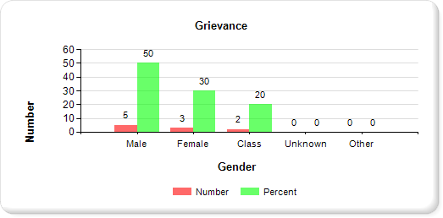
Graph 2A: Holly Center grievance data (t=10) by gender.

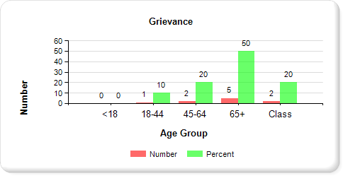
Graph 2B: Holly Center grievance data (t=10) by age.

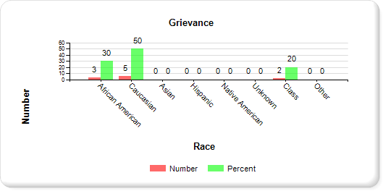
Graph 2C: Holly Center grievance data (t=10) by race.

Potomac Center

Grievance Cases by Gender, Age Group, and Race
SEX | # | % | AGE | # | % | RACE | # | %
Male | 23 | 74.19 | <18 | 0 | 0 | African  American | 19 | 61.29
Female | 7 | 22.58 | 18-44 | 23 | 74.19 | Caucasian | 8 | 25.81
 |  |  | 45-64 | 8 | 25.81 | Asian | 0 | 0
 |  |  | 65+ | 0 | 0 | Hispanic | 0 | 0
 |  |  |  |  |  | Native  American | 0 | 0
Other | 1 | 3.23 | Other | 0 | 0 | Other | 0 | 0
Unknown | 0 | 0 | Unknown | 0 | 0 | Unknown | 4 | 12.9
Class | 0 | 0 | Class | 0 | 0 | Class | 0 | 0
Total | 31 | 100 | Total | 31 | 100 | Total | 31 | 100
Chart 3: During FY 20, Potomac Center had a total of 31 grievances.

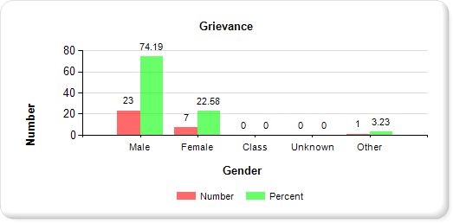
Graph 3A: Potomac Center grievance data (t=31) by gender.

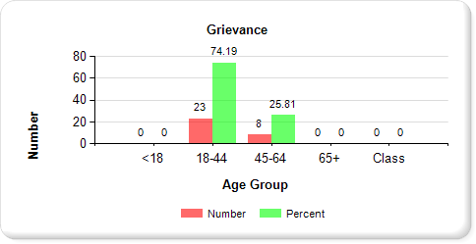
Graph 3B: Potomac Center grievance data (t=31) by age.

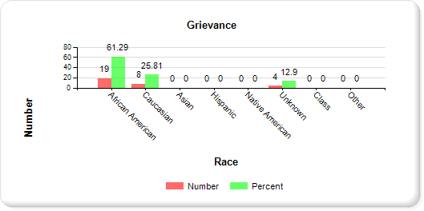
Graph 3C: Potomac Center grievance data (t=31) by race.

Secure Evaluation and Therapeutic Treatment (SETT) - Springfield

Grievance Cases by Gender, Age Group, and Race
SEX | # | % | AGE | # | % | RACE | # | %
Male | 11 | 36.67 | <18 | 0 | 0 | African  American | 11 | 36.67
Female | 16 | 53.33 | 18-44 | 25 | 83.33 | Caucasian | 14 | 46.66
 |  |  | 45-64 | 2 | 6.67 | Asian | 0 | 0
 |  |  | 65+ | 0 | 0 | Hispanic | 0 | 0
 |  |  |  |  |  | Native  American | 0 | 0
Other | 0 | 0 | Other | 0 | 0 | Other | 2 | 6.67
Unknown | 0 | 0 | Unknown | 0 | 0 | Unknown | 0 | 0
Class | 3 | 10 | Class | 3 | 10 | Class | 3 | 10
Total | 30 | 100 | Total | 30 | 100 | Total | 30 | 100
Chart 4: During FY 20, SETT Springfield had a total of 30 grievances.

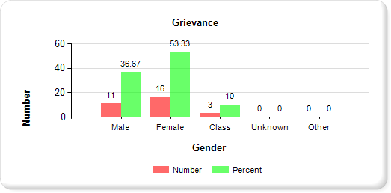
Graph 4A: SETT Springfield grievance data (t=30) by gender

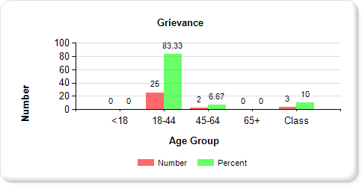
Graph 4B: SETT Springfield grievance data (t=30) by age.

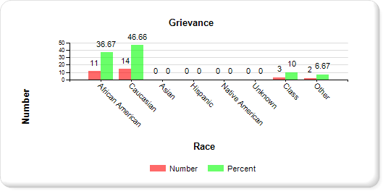
Graph 4C: SETT Springfield grievance data (t=30) by race.

SECTION B

INFORMATION AND ASSISTANCE (IA) DATA - FY 2020

IA Cases by Gender, Age Group, and Race – DDA
SEX | # | % | AGE | # | % | RACE | # | %
Male | 326 | 56.4 | <18 | 0 | 0 | African  American | 274 | 47.4
Female | 237 | 41 | 18-44 | 488 | 84.43 | Caucasian | 226 | 39.1
 |  |  | 45-64 | 79 | 13.67 | Asian | 0 | 0
 |  |  | 65+ | 8 | 1.38 | Hispanic | 0 | 0
 |  |  |  |  |  | Native  American | 0 | 0
Other | 12 | 2.08 | Other | 0 | 0 | Other | 3 | 0.52
Unknown | 0 | 0 | Unknown | 0 | 0 | Unknown | 72 | 12.46
Class | 3 | 0.52 | Class | 3 | 0.52 | Class | 3 | 0.52
Total | 578 | 100 | Total | 578 | 100 | Total | 578 | 100
Chart 5: During FY 20, DDA facilities had a total of 578 IA cases for the two DDA Residential Centers and the Secure Evaluation and Therapeutic Treatment (SETT) Unit.

Other = information collected from residents who selected this category as their gender and/or race.
Unknown = information collected from residents who chose not to identify gender and/or race.
Class = an IA case initiated by a group of residents who cannot be assigned to any gender, age group or race.

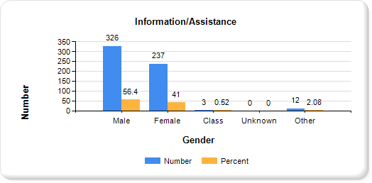
Graph 5A: DDA aggregate IA data (t=578) by gender.

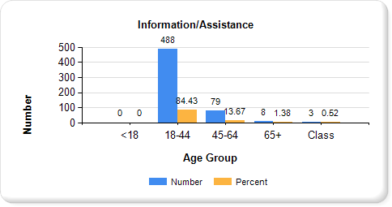
Graph 5B: DDA aggregate IA data (t=578) by age.

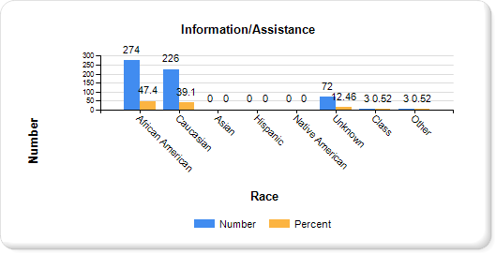
Graph 5C: DDA aggregate IA data (t=578) by race

Holly Center
IA Cases by Gender, Age Group, and Race
SEX | # | % | AGE | # | % | RACE | # | %
Male | 26 | 76.47 | <18 | 0 | 0 | African  American | 10 | 29.41
Female | 8 | 23.53 | 18-44 | 10 | 29.41 | Caucasian | 24 | 70.59
 |  |  | 45-64 | 16 | 47.06 | Asian | 0 | 0
 |  |  | 65+ | 8 | 23.53 | Hispanic | 0 | 0
 |  |  |  |  |  | Native  American | 0 | 0
Other | 0 | 0 | Other | 0 | 0 | Other | 0 | 0
Unknown | 0 | 0 | Unknown | 0 | 0 | Unknown | 0 | 0
Class | 0 | 0 | Class | 0 | 0 | Class | 0 | 0
Total | 34 | 100 | Total | 34 | 100 | Total | 34 | 100
Chart 6: During FY 20, Holly Center had a total of 34 IA cases.

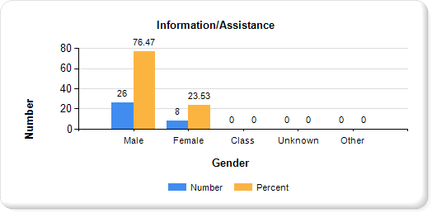
Graph 6A: Holly Center IA data (t=34) by gender.
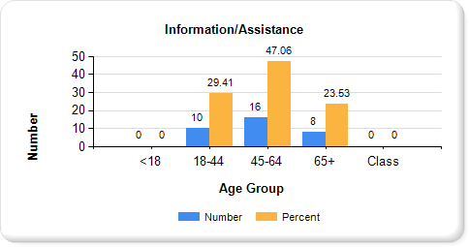
Graph 6B: Holly Center IA data (t=34) by age.

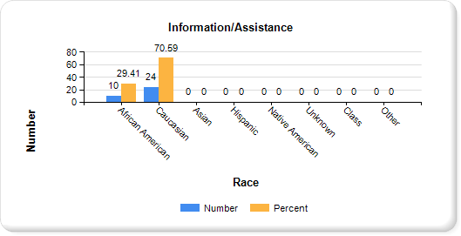
Graph 6C: Holly Center IA data (t=34) by race.

Potomac Center

IA Cases by Gender, Age Group, and Race
SEX | # | % | AGE | # | % | RACE | # | %
Male | 164 | 48.67 | <18 | 0 | 0 | African  American | 190 | 56.38
Female | 161 | 47.77 | 18-44 | 296 | 87.83 | Caucasian | 81 | 24.04
 |  |  | 45-64 | 41 | 12.17 | Asian | 0 | 0
 |  |  | 65+ | 0 | 0 | Hispanic | 0 | 0
 |  |  |  |  |  | Native  American | 0 | 0
Other | 12 | 3.56 | Other | 0 | 0 | Other | 0 | 0
Unknown | 0 | 0 | Unknown | 0 | 0 | Unknown | 66 | 19.58
Class | 0 | 0 | Class | 0 | 0 | Class | 0 | 0
Total | 337 | 100 | Total | 337 | 100 | Total | 337 | 100
Chart 7: During FY 20, Potomac Center had a total of 337 IA cases.

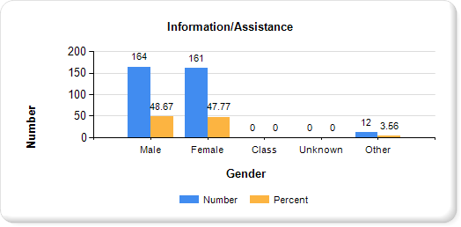
Graph 7A: Potomac Center IA data (t=337) by gender.

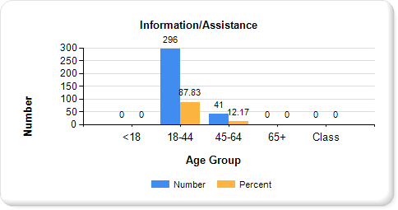
Graph 7B: Potomac Center IA data (t=337) by age.

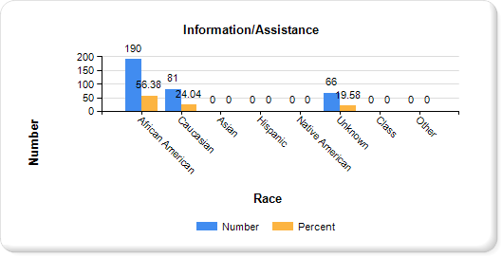
Graph 7C: Potomac Center IA data (t=337) by race.

Secure Evaluation and Therapeutic Treatment (SETT) - Springfield

IA Cases by Gender, Age Group, and Race
SEX | # | % | AGE | # | % | RACE | # | %
Male | 136 | 65.7 | <18 | 0 | 0 | African  American | 74 | 35.75
Female | 68 | 32.85 | 18-44 | 182 | 87.92 | Caucasian | 121 | 58.45
 |  |  | 45-64 | 22 | 10.63 | Asian | 0 | 0
 |  |  | 65+ | 0 | 0 | Hispanic | 0 | 0
 |  |  |  |  |  | Native American | 0 | 0
Other | 0 | 0 | Other | 0 | 0 | Other | 3 | 1.45
Unknown | 0 | 0 | Unknown | 0 | 0 | Unknown | 6 | 2.9
Class | 3 | 1.45 | Class | 3 | 1.45 | Class | 3 | 1.45
Total | 207 | 100 | Total | 207 | 100 | Total | 207 | 100
Chart 8: During FY 20, SETT Springfield had a total of 207 IA cases.

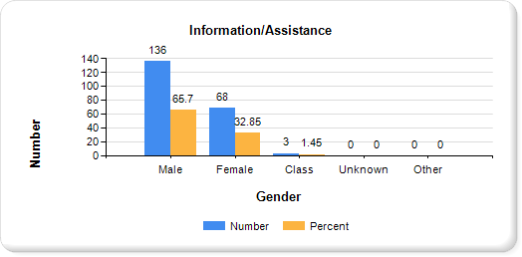
Graph 8A: SETT Springfield IA data (t=207) by gender.

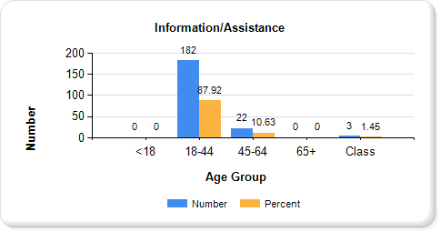
Graph 8B: SETT Springfield IA data (t=207) by age.

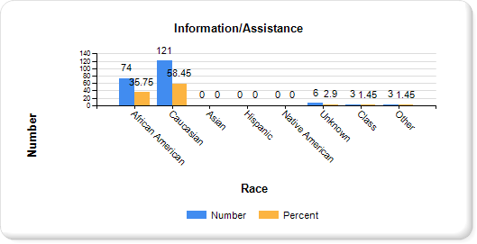
Graph 8C: SETT Springfield IA data (t=207) by race.

RESIDENT GRIEVANCE SYSTEM

Rhonda Callum, Director
201 West Preston Street, Room 546

Baltimore, Maryland 21201
1-800-747-7454

Effective July 1, 2017, the Department of Health and Mental Hygiene was renamed to the Maryland Department of Health (MDH).
Effective July 1, 2014, the Mental Hygiene Administration and Alcohol and Drug Abuse Administration combined to become the Behavioral Health Administration (BHA).

