DDA Inpatient Facilities
Rhonda Callum, Director John Hancock, Data Program Manager

RESIDENT GRIEVANCE SYSTEM
Maryland Department of Health Office of the Deputy Secretary of Behavioral Health Fiscal Year 2017

Table of Contents

PART I – RESIDENT GRIEVANCE SYSTEM
Background & Structure of Patients’ Rights Program 3
Resident Grievance System 3
Legal Assistance Providers 5
CLASSIFICATION OF RIGHTS
Grievances 7
Stage One 7
Stage Two 7
Stage Three 7
Stage Four 8
Information and Assistance 8
Rights Categories 9
Annual Data 13

PART II – FACILITY DATA
Section A: Grievance Data 14
Aggregate DDA Facilities 14
Holly Center 16
Potomac Center 18
Secured Evaluation Therapeutic Treatment - Springfield 20
Section B: Information and Assistance Data 22
Aggregate DDA Facilities 22
Holly Center 24
Potomac Center 26
Secured Evaluation Therapeutic Treatment - Springfield 28

PART I

RESIDENT GRIEVANCE SYSTEM
Developmental Disabilities Administration (DDA)
State Residential Centers
and the
Secured Evaluation Therapeutic Treatment Unit (SETT)
Fiscal Year 2017

Background & Structure of the Resident Grievance System

The Resident Grievance System was established in 1985 as part of a negotiated settlement of the class action lawsuit, Coe v Hughes, et al. The negotiated settlement, titled the Coe Consent Decree, created a two tiered advocacy program to enforce rights guaranteed by federal and state laws and regulations; to assist patients with claims for benefits and entitlements; to achieve deinstitutionalization; and to assist patients in resolving civil legal problems. The program is governed by the Code of Maryland Regulations (COMAR) 10.21.14, entitled Resident Grievance System, adopted March 28, 1994 and amended January 26, 1998.

The Resident Grievance System is under the auspices of the Deputy Secretary for Behavioral Health within the Maryland Department of Health (MDH). At inception, the program provided services for residents of the seven Behavioral Health Administration’s (BHA)’s Psychiatric Inpatient Facilities.

On July 1, 2000, by order of the Secretary of MDH, RGS expanded to provide rights advocacy for residents of the State Residential Centers (SRCs), operated by the Developmental Disabilities Administration (DDA). The policy governing the operation of the RGS in DDA facilities was finalized and distributed to the facilities by the Director of DDA on December 19, 2002. The policy outlines the procedures governing the administrative process for receiving and investigating, in a timely manner, reports of injuries, deaths, physical, sexual or verbal abuse, and any other rights issues, in accordance with Health General §7-1003 (g), Annotated Code of Maryland.

In January, 2009, RGS began to provide services to the two Secured Evaluation and Therapeutic Treatment (SETT’S) Units operated by DDA. In November 2016, the two units merged into one SETT unit, located on the grounds of Springfield Hospital Center. The mission of the SETT unit is to provide evaluations, assessments and treatment to court-involved, intellectually disabled individuals, within a secure and safe environment.

Resident Grievance System
The first tier of Maryland’s patient rights program is the Resident Grievance System (RGS). The RGS is a four-stage administrative grievance procedure designed to protect the rights of patients in the BHA and DDA facilities, and to provide a timely, fair, efficient, and complete mechanism for receiving, investigating, and resolving residents’ complaints. The central function of the RGS is the resolution of grievances through mediation, negotiation, or conciliation, while representing the best interest of the patients. It is designed to be non-adversarial and to ensure that both clinical and legal considerations are properly balanced.

RGS collaboratively works with the Office of Health Care Quality, Disabilities Rights Maryland (DRM) and other stakeholders to ensure patient safety and the protection of their legal rights. RAs are responsible for investigating and mediating allegations of rights violations, and providing patient rights education to residents and staff in DDA SRC facilities and SETT Unit. They also help protect the civil rights (voting, confidentiality, etc.) of patients. RAs have satellite offices at each facility. This allows them to attend and participate in various committees and facility meetings, to address patients’ concerns, and to advocate for patients’ rights. To ensure patient services are not interrupted for any reason, all RAs are trained to provide RGS services within any of the SRCs and SETT unit.

In January 1996, the RGS implemented toll-free telephone access. This service allows residents to have immediate contact with the RGS and has enhanced the ability to respond rapidly to patient concerns. Referrals to the RGS can be made directly to the assigned RA or the Central Office by using the toll-free number, 1-800-747-7454. During FY 17, RGS received a total of 2,684 calls via the toll-free number. Graph 1 details the number of calls received per month during FY 17. Graph 2 details the average number of calls received per day for each month of FY 17.

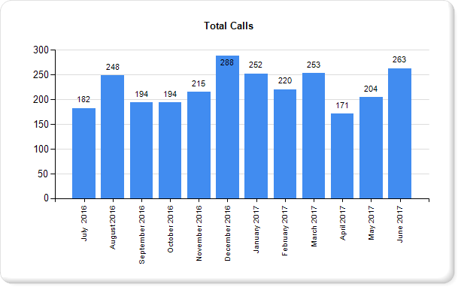
Graph 1 represents the total calls received from the toll-free number by month for FY 2017.

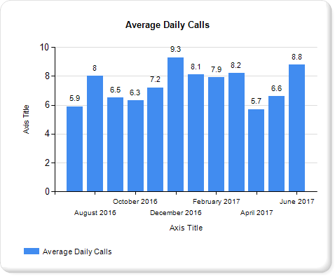
Graph 2 represents the average daily calls by month received from the toll-free number for FY 2017.

Legal Assistance Providers
Legal Assistance Providers (LAPs) are the second tier of the patient rights program. LAPs are a group of independent attorneys, contracted by RGS, to provide the following specific legal assistance and representation to residents within DDA facilities pursuant to Annotated Code of Maryland, Health General §7-503:

- Admission Hearings – LAPs provide representation on behalf of individuals proposed for admission to a State Residential Center. In Fiscal Year 2017, LAPs spent 62 hours representing 10 individuals at admission hearings. HG §7-503 requires a showing – by clear and convincing evidence – that the conclusions leading to the decision to admit an individual are supported by the following findings:

- The individual has mental retardation;

- The individual needs residential services for the individual’s adequate habilitation; and

- There is no less restrictive setting in which the needed services can be provided that is available to the individual, or will be available to the individual within a reasonable time after the hearing.
- Annual Reviews – LAPs provide representation for residents at an annual review of their current status, to determine whether they continue to meet retention criteria. HG §7-505, requires a determination of the following:
- Whether this individual continues to meet the requirements of this subtitle for admission to a State Residential Center;

- Whether the services which the individual requires can be provided in a less restrictive setting;

- Whether the individual’s plan of habilitation as required by §7-1006 of this title is adequate and suitable; and

- Whether the State residential center has complied with and executed the individual’s plan of habilitation in accordance with the rules, regulations, and standards that the Secretary adopts.

- Habeas Corpus / Petition for Release - LAPs provide representation for residents who request to apply for a writ of Habeas Corpus or petition for release.

- §7-506 Habeas Corpus - Any individual who has been admitted to a State residential center or any person on behalf of the individual may apply at any time to a court of competent jurisdiction for a writ of habeas corpus to determine the cause and the legality of the detention.

- §7-507 Petition for Release - Subject to the limitations in this section, a petition for the release of an individual who is held under this subtitle from a State residential center may be filed, at any time, by the individual or any person who has a legitimate interest in the welfare of the individual.

- Transfer Hearings - LAPs provide representation for residents at transfer hearings. Below are the requirements for resident transfers:

- §7-801 Authority of Director - The Director may transfer an individual with a developmental disability from a public residential program or a public day program to another public residential program or public day program or if a private provider of services agrees to that private program. Such transfers are permitted if the Director finds that the individual with developmental disabilities can (1) receive better treatment in, or would be more likely to benefit from, treatment at the other program; or (2) the safety or welfare of other individuals with developmental disabilities would be furthered.

- §7-802 Transfer to a Mental Health Program - DDA may ask BHA to accept primary responsibility for a resident in a SRC, or an individual eligible for admission to a SRC, if DDA finds that the individual would be provided for more appropriately in a program for individuals with mental disorders. BHA shall determine whether it would be appropriate to transfer the individual to a mental health program.

- A dispute over a transfer of an individual from DDA to BHA shall be resolved in accordance with procedures that the Secretary sets, on request of DDA or BHA. The Director shall give the individual with developmental disability the opportunity for a hearing on the proposed transfer.

CLASSIFICATION OF RIGHTS
- Grievances
A “Grievance” is defined as a written or oral statement which alleges either A) that an individual’s rights have been unfairly limited, violated, or are likely to be violated in the immediate future, or B) that the facility has acted in an illegal or improper manner with respect to an individual, or a group of individuals. Grievances can be initiated by the individual, an employee of the facility, a family member of the individual, or an interested party.

Grievance management, a major responsibility of the RA, includes receipt, investigation and resolution of complaints, as well as compliance with the systematic and orderly four-stage grievance process. At each stage, grievances are determined to be Valid, Invalid, or Inconclusive. A grievance is Valid when evidence is sufficient to prove an allegation. When there is insufficient evidence to prove an allegation, a grievance is Invalid. A grievance is Inconclusive when sufficient evidence does not exist to prove or disprove an allegation. The four stages of the grievance process are described below:

Stage One -- This is the beginning of the four-stage grievance process. During Stage One, the RA receives a complaint from a resident or an individual filing the grievance on behalf of the resident. Once received, the RA determines an appropriate course of action for investigating the grievance, which may include (1) interviewing everyone involved; (2) requesting documents, statements and correspondence related to the grievance; or (3) discussing the clinical review panel process to residents who refuse to take medication prescribed for the treatment of a mental disorder. The RA has 10 working days from receipt of a grievance to gather information, complete an investigation and render a decision. The resident, or the individual filing the grievance on behalf of the resident, is informed of the decision and the right to appeal to the next stage. RAs make every effort to negotiate, mediate and work toward the achievement of a mutually satisfactory resolution at Stage One.

Stage Two -- If unresolved at Stage One, a grievance proceeds to Stage Two for review, investigation and recommendations by the Unit Director. The unit director shall (1) review the RA’s report; (2) discuss the matter with all involved individuals; and (3) within five working days of receipt of the report, render a written decision regarding the grievance and return it to the RA. The RA informs the grievant of the Stage Two decision and their right to appeal to Stage Three.

Stage Three - If unresolved at Stage Two, the grievance proceeds to Stage Three for review, corrective action if applicable, and/or recommendations by the Chief Executive Officer (CEO), with an optional review by the Resident’s Rights Committee (RRC). Stage Three is divided into two stages – Stage 3A and Stage 3B.
- Stage 3A - The grievant has a right to request a review by the RRC at Stage 3A, prior to the 3B review by the facility’s Chief Executive Officer (CEO). If the grievant requests a review by the RRC, the Committee will meet within 15 working days of receipt of the grievance to review the RA’s report and the unit director’s decision. At this stage, the grievant has the right to attend and present information to the Committee, and to be represented by the LAP. Once all relevant reports and information presented are reviewed, the RRC will forward written recommendations to the CEO.

- Stage 3B – Upon receipt of the grievance, the CEO will review all information from the previous stages. If the CEO finds the grievance to be Valid, the CEO will document in the report, the corrective action to be taken to remedy the violation against the resident. If the CEO finds the grievance Invalid, the decision is forwarded to the RA. The resident is informed of the decision and the right to appeal to Stage Four. The CEO may find the grievance Inconclusive and recommend the grievance is forwarded to Stage Four for a decision by the Central Review Committee.

Stage Four -- Unresolved Stage Three grievances are referred to Stage Four, where they are reviewed by the Central Review Committee (CRC). A CRC appeal is the last and final appeal level of the RGS. A RA is required to make every effort to negotiate, mediate, and resolve the grievance during earlier stages of the RGS. However, the ultimate decision to resolve or appeal the grievance belongs to the patient or the individual submitting the grievance on behalf of the patient. If the patient elects to appeal, the RA is required to assist the patient in filing the appeal, even though the RA may not believe that the request has merit.

The CRC is composed of three members: Director of the RGS, Executive Director of BHA, and Clinical Director of BHA, or their designees. The Committee reviews all prior information and recommendations concerning the grievance, and may request additional documents or records from the facility, prior to rendering a decision. At the conclusion of the review, the Committee issues a written decision to the facility based on its findings, and makes recommendations for corrective action, if warranted. The RGS Director is responsible for monitoring the implementation of all corrective action recommended by the Committee. Residents are notified in writing of the Stage Four decision and the RA provides the patients with additional community resources in the event they are still not satisfied with the Stage Four decision.

The RA has oversight of the grievance process, ensuring that the four stages are completed within 65 working days, as required by COMAR 10.21.14.

In Fiscal Year 2017, RAs processed a total of 61 grievances. Of those 61 grievances, 22 (36%) were resolved at Stage 1, 19 (31%) were resolved at Stage 2, 19 (31%) were resolved at Stage 3 and 1 (2%) was resolved at Stage 4. Potomac Center submitted the one grievance appealed to the Central Review Committee in FY 17.

Information/Assistance
Cases classified as Information/Assistance do not allege a rights violation, but are contacts in which the patient is seeking information, clarification, or assistance with a concern. In Fiscal Year 2017, RAs provided Information and assistances to 334 residents, 85% of the total 395 patient contacts.
The following chart lists the totals of two of the three major classifications (grievances and IA cases) for each of the three DDA inpatient facilities. DDA residents are not forced to take medication. Consequently, CRPs are not held in DDA facilities. Effective November 16, 2016, the two DDA Secure Evaluation Therapeutic Treatment (SETT) Units merged into one SETT unit, located on the grounds of Springfield Hospital Center. No cases were opened in FY 17 at SETT Perkins prior to the merge.

AGGREGATE MAJOR CLASSIFICATIONS BY FACILITY
Facility | Grievances | Information  Assistance | Facility Totals
Holly Center | 3 | 41 | 44
Potomac Center | 51 | 257 | 308
SETT - Springfield | 7 | 36 | 43
SETT – Perkins (closed) | 0 | 0 | 0
Activity Total | 61 | 334 | 395

- Rights Categories
All patients are entitled to certain rights guaranteed by, and explained in, Health General Article of Maryland’s Annotated Code, 10-701 to 10-713. The sixteen major categories have been developed to uniformly identify and assign patient complaints to the stipulated rights of patients in Health General Article Annotated Code of Maryland. Based on patients’ rights guaranteed by Federal and State constitutions, statutes, regulations, common law, or policies of the Department, Behavioral Health Administration, and the facility, the sixteen major rights categories have been identified below and are subject to any reasonable limitation that a facility or guardian may impose.

- Abuse – Patients have the right to be protected from physical, mental or verbal harm. Abuse is defined as cruel or inhumane treatment or an intentional act that causes injury or trauma to another person. Physical abuse is an intentional act that causes injury or trauma by physical, bodily contact, such as hitting, grabbing, shoving, punching or kicking. Sexual abuse is an intentional, unwanted, forced sexual act or threat used to take advantage of an individual not able to give consent, such as unwanted touching, forced sex, or sexually suggestive language. Mental abuse is any intentional act that causes emotional injury or trauma resulting in a diminished sense of self-worth, dignity or identity, such as yelling, swearing, name calling, insults, threats, intimidation, humiliation, or bullying.

- Admission / Discharge / Transfer:
- Admission - Upon admission, patients have a right to receive information which describes the patient’s admission status, the availability of legal services, the right to talk to a lawyer of choice and their rights while in the hospital. The person has a right to ask questions concerning their admission status and should be provided that opportunity.

- Discharge - The hospital must discharge any patient not committed by the court who is not mentally ill. If committed involuntarily, the treatment team determines when an individual’s condition has stabilized sufficiently for that person to return to the community. Court appointed patients must receive approval by the judge prior to discharge.

- Transfer – The hospital may transfer patients to another State facility if (1) the patient can benefit from or receive better care or treatment at another facility; or (2) if it is for the protection, safety or welfare of others. However, the patient has a right to be notified of the transfer and have a hearing held prior to the transfer UNLESS an emergency situation exists. In the event of an emergency transfer, the patient has a right to a hearing within 10 days after the transfer.

- Civil Rights – Patients have the same basic rights of all citizens in society. Patients may not be deprived of any civil right such as the right to vote, to receive hold, and dispose of property, or to practice the religion or faith of choice, solely because the individual is in a facility for a mental disorder.

- Communication / Visits - Patients have the right to send and receive mail, have reasonable use of the telephone and receive visitors during reasonable visiting hours that are set by the facility.

- Confidentiality – Patients have the right to have their medical records and information kept confidential and the right to review their medical record upon request, within a reasonable timeframe.

- Environmental – Patients have the right to live with dignity in a safe, clean and sanitary facility. Environmental rights include the right to bath and have personal hygiene needs met, to have clean clothes and bed linens, and to have nutritious meals provided daily.

- Freedom of Movement – Patients personal liberty can only be restricted based on treatment needs and applicable legal requirements. They have the right to be free from restraint or seclusion except when used during an emergency in which the behavior of the patient places the patient or others at serious threat of violence or injury. The restraint or seclusion must be ordered by a physician, in writing, or directed by a registered nurse, if a physician’s order is obtained within 2 hours of the action. Patients have the right to voluntarily request the use of the Quiet Room.

- Money – Patients have the right to a bank account, to have the facility hold money for safekeeping and to access their funds when requested. Patients also have a right to apply for State and federal entitlements and benefits.

- Neglect – The definition of neglect is the failure to properly attend to the needs and care of a patient. Patients have the right to have staff attentive to their needs and to be taken care of with dignity and respect.

- Personal Property – Patients have the right to a reasonable amount of personal property that is not considered contraband or a danger to the patient or others. Patients have a right to receive and store personal property in secure containers and applicable storage units provided by the facility to prevent theft, loss or destruction of their property.

- Rights Protection System – Patients have a right to complain and to get assistance to resolve complaints. The RGS is responsible for ensuring that the rights of patients in BHA and DDA facilities are fully protected and allegations of rights’ violations ae investigated and resolved in a timely manner.

- Treatment Rights – Patients have the right to participate in their treatment and the development and periodic updating of their treatment plans. They have the right to be told in appropriate and understandable language:
The content and objectives of the plan;

- The nature and significant possible adverse effects of recommended treatments;

- Information concerning alternative treatment or mental health services that are available, when appropriate;

- The right to have family, or an advocate, participate in treatment team meetings; and

- The right to refuse medication used for treatment of a mental disorder except in an emergency, when there is a present danger to life or safety of the patient or others; or in a non-emergency, when involuntarily committed or court ordered for treatment by the court, and the medication is approved by a CRP.

- Other Rights – Patients have the right to seek assistance, either from a LAP or private attorney, for legal issues outside the jurisdiction of the RGS.

- Resident to Resident Assault – A patient who is assaulted by another patient has the right to press charges against the other patient. RAs do not investigate the incident unless the assault occurred as a result of staff’s’ neglect. RAs inform all victims that they have one year and a day to report in person to the police department and press formal charges.

- Death - All deaths in a State funded or operated program or facility, are required to be reported immediately to law enforcement within the jurisdiction in which the death occurred, to the Secretary of MDH, the Health Officer in the jurisdiction where the death occurred, the Office of Health Care Quality, the designated State protection and advocacy agency and the Director of RGS.

- No Rights Involved –. This category is for cases that do not involve a rights violation.

Depending on the allege rights violation, grievances and IAs can be assigned to any one of the major sixteen rights categories. Listed below in charts A-B are the number of grievances and IA cases that fell into each of the sixteen rights categories described above for each DDA facility.

Chart A - Grievances
Rights Category | Holly Center | Potomac Center | SETT Springfield | SETT Perkins
Abuse | 1 | 36 | 0 | 0
Admission / Discharge / Transfer | 0 | 0 | 1 | 0
Civil Rights | 0 | 2 | 1 | 0
Communication / Visits | 0 | 1 | 0 | 0
Confidentiality | 0 | 0 | 1 | 0
Environmental | 0 | 4 | 2 | 0
Freedom of Movement | 0 | 1 | 0 | 0
Money | 0 | 0 | 1 | 0
Neglect | 1 | 2 | 0 | 0
Personal Property | 0 | 2 | 0 | 0
Rights Protection System – RGS | 0 | 1 | 0 | 0
Treatment Rights | 1 | 0 | 1 | 0
Other | 0 | 0 | 0 | 0
No Rights Involved | 0 | 0 | 0 | 0
Resident to Resident Assault | 0 | 2 | 0 | 0
Death | 0 | 0 | 0 | 0
TOTAL | 3 | 51 | 7 | 0
Chart A lists the total grievances assigned to each of the 16 rights categories for each DDA facility.

Chart B - Information/Assistance
Rights Category | Holly Center | Potomac Center | SETT Springfield | SETT Perkins
Abuse | 0 | 14 | 0 | 0
Admission / Discharge / Transfer | 0 | 1 | 0 | 0
Civil Rights | 0 | 5 | 1 | 0
Communication / Visits | 0 | 5 | 1 | 0
Confidentiality | 0 | 0 | 0 | 0
Environmental | 1 | 13 | 0 | 0
Freedom of Movement | 0 | 37 | 6 | 0
Money | 0 | 2 | 4 | 0
Neglect | 2 | 11 | 0 | 0
Personal Property | 0 | 7 | 0 | 0
Rights Protection System – RGS | 0 | 3 | 8 | 0
Treatment Rights | 31 | 14 | 2 | 0
Other | 1 | 3 | 0 | 0
No Rights Involved | 0 | 4 | 0 | 0
Resident to Resident Assault | 1 | 138 | 14 | 0
Death | 5 | 0 | 0 | 0
TOTAL | 41 | 257 | 36 | 0
Chart B lists the total IA cases assigned to each of the 16 rights categories for each DDA facility.

ANNUAL DATA – GRIEVANCES AND IA CASES

Chart C below depicts the total grievances and IA cases for all three DDA facilities combined. As stated earlier, DDA residents are not forced to take medication and as a result, CRPs are not held in DDA facilities. Consequently, only grievances and IA cases are reported. The total number of grievances and IA cases are input into the RGS database for each facility by the RA(s) assigned to that facility. In turn, the information is collected and aggregate totals are calculated by combining individual facility totals. However, current year data alone cannot provide any information regarding trends or discrepancies in the data from year to year. Observing data over time can determine whether an actual change has occurred. Comparing data within and between the two major classifications across a five year span can point out significant increases or decreases, reveal significant patterns, and point out significant changes. The data in the chart below provides information regarding annual total cases for the two major classifications - grievances and IAs – across a five years (2013-2017).

Annual Data 2013 - 2017
Year | 2013 | 2014 | 2015 | 2016 | 2017
Grievances | 12 | 27 | 8 | 8 | 61
IAs | 535 | 521 | 733 | 808 | 334
Totals | 547 | 548 | 741 | 816 | 395
Chart C: While there were no consistent trends in the grievance data for the last
five years, FY 17 reported a drastic increase in the number of grievances compared
to the prior four years. Although IA cases remain the largest number of cases handled
by RAs, FY17 reported a significant drop in the number of IA cases. This may be due
to a staff vacancy in FY 17.

PART II: FACILITY DATA – FY 2017

This section provides facility data for each of the three DDA facilities for the two major types of patient interactions – grievances and IAs. The major interactions are, in turn, reported by data and percentages within three demographic categories - gender, age group and race. The numbers and percentages for each category are listed in a chart, followed by a set of graphs. The first chart in section A (grievances) and B (IA cases) reports aggregate information for all DDA facilities combined. Data for the individual facilities are then listed. The charts and graphs provide valuable information regarding the “number” and “type” of complaints received and the demographic profile of the patients initiating the cases, specific to each facility.

Section A reports grievance data by gender, age group and race. The first chart and set of graphs list the total grievances and percentages by category for all three DDA facilities. Following the aggregate DDA grievance data, each individual facility has a chart and set of graphs that list that facility’s grievances by gender, age group and race.

Section B reports IA data by gender, age group and race. Aggregate DDA IA information is provided for all three facilities, followed by IA numbers for each individual DDA facility.

SECTION A: GRIEVANCE DATA - FY 2017

Chart 1: Aggregate Grievance Cases by Gender, Age Group and Race – DDA
SEX | # | % | AGE | # | % | RACE | # | %
Male | 37 | 61 | <18 | 0 | 0 | African  American | 37 | 61
Female | 24 | 39 | 18-44 | 54 | 89 | Caucasian | 20 | 33
 |  |  | 45-64 | 7 | 11 | Asian | 0 | 0
 |  |  | 65+ | 0 | 0 | Hispanic | 4 | 6
 |  |  |  |  |  | Other | 0 | 0
Class | 0 | 0 | Class | 0 | 0 | Class | 0 | 0
Total | 61 | 100 | Total | 61 | 100 | Total | 61 | 100
Chart 1: During FY 17, there were a total of 61 grievances reported for all three (3) DDA inpatient facilities.

The following set of graphs represent the aggregate grievances and respective percentages for Holly Center, Potomac Center and SETT Springfield by gender, age group and race.

Chart 1A: Grievance Cases by Gender for All DDA Inpatient Facilities
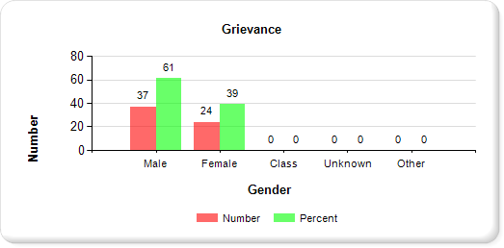
Chart 1A represents the total number of grievances (61) for the three DDA inpatient facilities for
FY 17, reported by gender. Of the 61 grievances, 37 (61%) were submitted by male residents; and
24 (39%) were submitted by female residents.

Chart 1B: Grievance Cases by Age Group for All DDA Inpatient Facilities
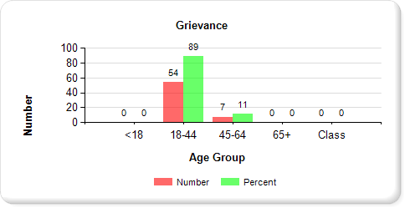
Chart 1B represents the 61 grievances reported by age group. Of the 61 total cases, 54
(89%) were submitted by residents between 18-44 years of age; and seven (11%) were
submitted by residents 45-64 years of age.

Chart 1C: Grievance Cases by Race for All DDA Inpatient Facilities
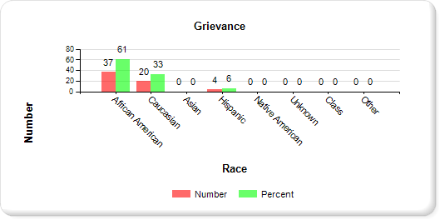
Chart 1C represents the total number of grievances (61), reported by race. Of the 61 grievances, 37 (61%) were submitted by African American residents; 20 (33%) were submitted by Caucasian residents; and
four (6%) were submitted by Hispanic residents.

Chart 2: Grievance Cases by Gender, Age Group and Race – Holly Center
SEX | # | % | AGE | # | % | RACE | # | %
Male | 2 | 67 | <18 | 0 | 0 | African  American | 0 | 0
Female | 1 | 33 | 18-44 | 3 | 100 | Caucasian | 3 | 100
 |  |  | 45-64 | 0 | 0 | Asian | 0 | 0
 |  |  | 65+ | 0 | 0 | Hispanic | 0 | 0
 |  |  |  |  |  | Other | 0 | 0
Class | 0 | 0 | Class | 0 | 0 | Class | 0 | 0
Total | 3 | 100 | Total | 3 | 100 | Total | 3 | 100
Chart 2: During FY 17, there were a total of three grievances reported for Holly Center.

The following set of graphs represent the total grievances and percentages for Holly Center by gender, age group and race.

Chart 2A: Grievance Cases by Gender for Holly Center
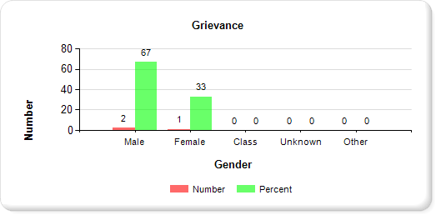
Chart 2A represents the total number of grievances (three) reported by gender. Of the three
grievances reported, two (67%) were submitted by males and one (33%) was submitted by a female.

Chart 2B: Grievance Cases by Age Group for Holly Center
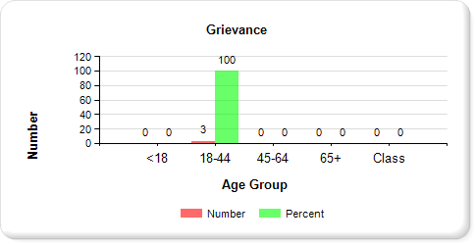
Chart 2B represents the three grievances reported by age group. All three grievances were
submitted by residents 18-44 years of age.

Chart 2C: Grievance Cases by Race for Holly Center
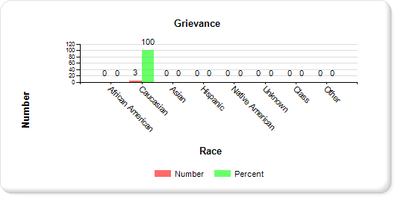
Chart 2C represents the three grievances reported by race. All three grievances were submitted by Caucasian residents.

Chart 3: Grievance Cases by Gender, Age Group and Race – Potomac Center
SEX | # | % | AGE | # | % | RACE | # | %
Male | 29 | 57 | <18 | 0 | 0 | African  American | 32 | 63
Female | 22 | 43 | 18-44 | 47 | 92 | Caucasian | 15 | 29
 |  |  | 45-64 | 4 | 8 | Asian | 0 | 0
 |  |  | 65+ | 0 | 0 | Hispanic | 4 | 8
 |  |  |  |  |  | Other | 0 | 0
Class | 0 | 0 | Class | 0 | 0 | Class | 0 | 0
Total | 51 | 100 | Total | 51 | 100 | Total | 51 | 100
Chart 3: During FY 17, there were a total of 51 grievances reported for Potomac Center.

The following set of graphs represent the total grievances and percentages for Potomac Center by gender, age group and race.

Chart 3A: Grievance Cases by Gender for Potomac Center
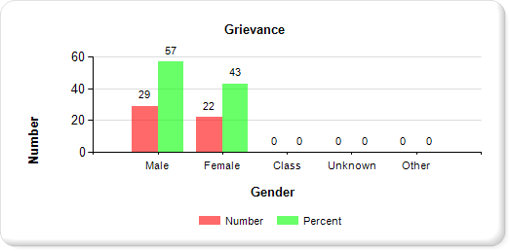
Chart 3A represents the total number of grievances (51) by gender. Of the 51 grievances, 29 (57%)
were submitted by male patients and 22 (43%) were submitted by female patients.

Chart 3B: Grievance Cases by Age Group for Potomac Center
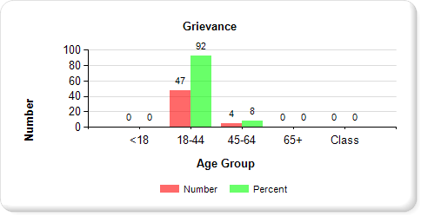
Chart 3B represents the total number of grievances (51) reported by age group. Of the 51
grievances, 47 (92%) were submitted by patients 18-44 years of age; and four (8%) were
submitted by patients 45-64 years of age.

Chart 3C: Grievance Cases by Race for Potomac Center
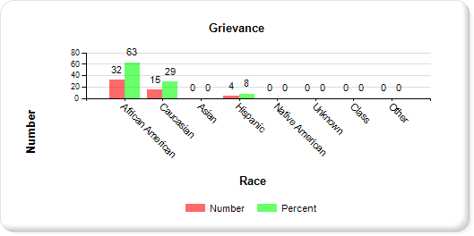
Chart 3C represents the total number of grievances (51) reported by race. Of the 51 grievances, 32 (63%) were submitted by African American residents; 15 (29%) were submitted by Caucasian residents and
four (8%) were submitted by Hispanic residents.

Chart 4: Grievance Cases by Gender, Age Group and Race
Secured Evaluation and Therapeutic Treatment (SETT) Springfield
SEX | # | % | AGE | # | % | RACE | # | %
Male | 6 | 86 | <18 | 0 | 0 | African  American | 5 | 71
Female | 1 | 14 | 18-44 | 4 | 57 | Caucasian | 2 | 29
 |  |  | 45-64 | 3 | 43 | Asian | 0 | 0
 |  |  | 65+ | 0 | 0 | Hispanic | 0 | 0
 |  |  |  |  |  | Other | 0 | 0
Class | 0 | 0 | Class | 0 | 0 | Class | 0 | 0
Total | 7 | 100 | Total | 7 | 100 | Total | 7 | 100
Chart 4: During FY 17, there were a total of seven grievances reported for SETT Springfield.

The following set of graphs represent the total grievances and respective percentages for SETT Springfield by gender, age group and race.

Chart 4A: Grievance Cases by Gender for SETT Springfield
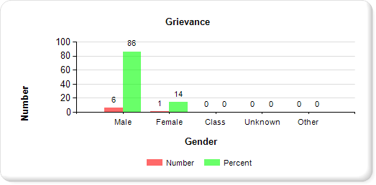
Chart 4A represents the total number of grievances (seven) reported by gender. Of the seven
grievances, six (86%) were submitted by male patient; and one (14%) was submitted by a female.

Chart 4B: Grievance Cases by Age Group for SETT Springfield
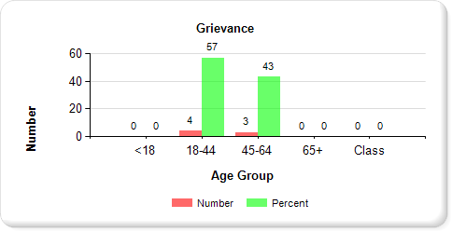
Chart 4B represents the total number of grievances (seven) reported by age group. Of the
seven grievances, four (57%) were submitted by patients 18-44 years of age; and three (43%)
were submitted by patients 45-64 years of age.

Chart 4C: Grievance Cases by Race for SETT Springfield
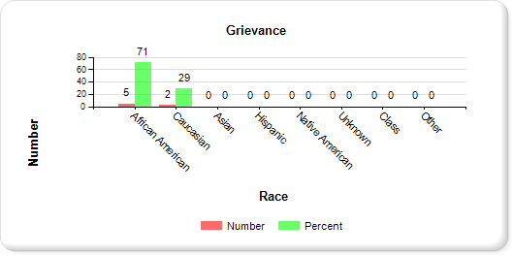
Chart 4C represents the total number of grievances (seven) reported by race. Of the seven grievances,
five (71%) were submitted by African American residents and two (29%) were submitted by Caucasian residents.

SECTION B

INFORMATION AND ASSISTANCE (IA) DATA - FY 2017

Chart 5: IA Cases by Gender, Age Group and Race – DDA
SEX | # | % | AGE | # | % | RACE | # | %
Male | 197 | 59 | <18 | 1 | 1 | African  American | 164 | 48
Female | 128 | 38 | 18-44 | 266 | 79 | Caucasian | 130 | 39
 |  |  | 45-64 | 54 | 16 | Asian | 1 | 1
 |  |  | 65+ | 4 | 1 | Hispanic | 30 | 9
 |  |  |  |  |  | Other | 0 | 0
Class | 9 | 3 | Class | 9 | 3 | Class | 9 | 3
Total | 334 | 100 | Total | 334 | 100 | Total | 334 | 100
Chart 5: During FY 17, there were a total of 334 IA cases reported for all three (3) DDA facilities. “Class” represents demographic information representative of a class action initiated by a group of residents and cannot be assigned to any of the specific demographic categories (sex, age and race) listed. There were a total of nine class action IA cases, representing 3% of all IA cases reported.

The following set of graphs represent the aggregate IA cases and respective percentages for the three DDA facilities, reported by gender, age group and race.

Chart 5A: IA Cases by Gender for All DDA Inpatient Facilities
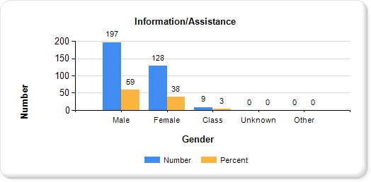
Chart 5A represents the total number of IA cases (334) for all DDA facilities, reported by gender. Of the 334 IA cases, 197 (59%) were submitted by males; 128 (38%) were submitted by females; and nine (3%) were class action IA cases, initiated by a group of patients not assigned to any specific gender.

Chart 5B: IA Cases by Age Group for All DDA Inpatient Facilities
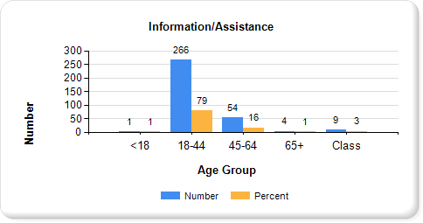
Chart 5B represents the total number of IA cases (334) reported by age group. Of the 334 total
cases, one (1%) was submitted by a resident < 18 years of age; 266 (79%) were submitted by
residents 18-44 years of age; 54 (16%) submitted by residents 45-64 years of age; four (1%)
were submitted by residents 65 years of age or older; and nine (3%) were class action IA cases,
initiated by a group of residents not assigned to any specific gender.

Chart 5C: IA Cases by Race for All DDA Inpatient Facilities
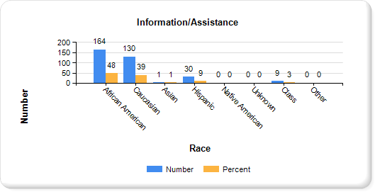
Chart 5C represents the total number of IA cases (334) reported by race. Of the 334 IA cases, 164 (48%)
were submitted by African American residents; 130 (39%) were submitted by Caucasian residents;
one (1%) IA case was Initiated by an Asian resident, 30 (9%) were initiated by Hispanic residents; and nine (3%) were class action IA cases, initiated by a group of patients not assigned to any specific gender.
Chart 6: IA Cases by Gender, Age Group and Race – Holly Center
SEX | # | % | AGE | # | % | RACE | # | %
Male | 28 | 68 | <18 | 0 | 0 | African  American | 7 | 17
Female | 13 | 32 | 18-44 | 10 | 25 | Caucasian | 33 | 81
 |  |  | 45-64 | 28 | 68 | Asian | 1 | 2
 |  |  | 65+ | 3 | 7 | Hispanic | 0 | 0
 |  |  |  |  |  | Other | 0 | 0
Class | 0 | 0 | Class | 0 | 0 | Class | 0 | 0
Total | 41 | 100 | Total | 41 | 100 | Total | 41 | 100
Chart 6: During FY 17, there were a total of 41 IA cases reported for Holly Center.

The following set of graphs represent the total IA cases and respective percentages for Eastern Shore Hospital by gender, age group and race.

Chart 6A: IA Cases by Gender for Holly Center
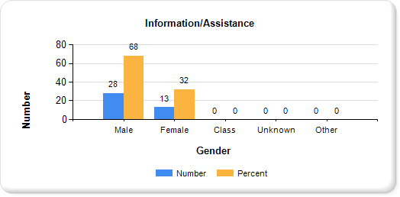
Chart 6A represents the total number of IA cases (41) reported by gender. Of the 41 total IA cases, 28 (68%) were submitted by males and 13 (32%) were submitted by females.

Chart 6B: IA Cases by Age Group for Holly Center
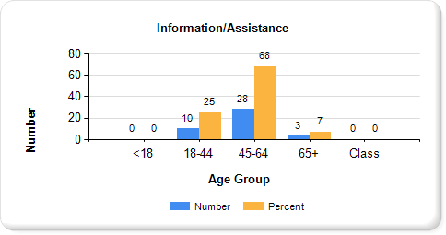
Chart 16B represents the total number of IA cases (41) reported by age group. Of the 41 total
cases, ten (25%) were submitted by residents 18-44 years of age; 28 (68%) were submitted
by residents 45-64 years of age; and three (7%) were submitted by residents 65 years of age or older.

Chart 6C: IA Cases by Race for Holly Center
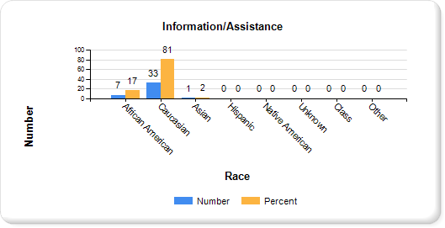
Chart 6C represents the total number of IA cases (41) reported by race. Of the 41 IA cases, seven (17%) were submitted by African American residents; 33 (81%) were submitted by Caucasian residents; and
one (2%) was submitted by an Asian resident..

Chart 7: IA Cases by Gender, Age Group and Race – Potomac Center
SEX | # | % | AGE | # | % | RACE | # | %
Male | 137 | 53 | <18 | 0 | 0 | African  American | 131 | 51
Female | 113 | 44 | 18-44 | 227 | 88 | Caucasian | 91 | 35
 |  |  | 45-64 | 22 | 8 | Asian | 0 | 0
 |  |  | 65+ | 1 | 1 | Hispanic | 28 | 11
 |  |  |  |  |  | Other | 0 | 0
Class | 7 | 3 | Class | 7 | 3 | Class | 7 | 3
Total | 257 | 100 | Total | 257 | 100 | Total | 257 | 100
Chart 11: During FY 17, there were a total of 257 IA cases reported for Potomac Center. There were seven class action IA case, representing 3% of all IA cases reported for this facility.

The following set of graphs represent the total IA cases and respective percentages for Potomac Center by gender, age group and race.

Chart 7A: IA Cases by Gender for Potomac Center
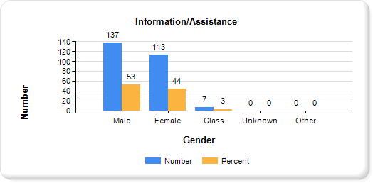
Chart 7A represent the total number of IA cases (257) reported by gender. Of the 257 cases, 137
(53%) were submitted by male residents; 113 (44%) were submitted by female residents; and seven (3%) were class action cases, initiated by a group of patients not assigned to any specific gender.

Chart 7B: IA Cases by Age Group for Potomac Center
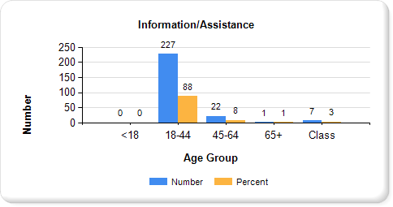
Chart 7B represents the total number of IA cases (257) reported by age group. Of the 257 IA
total cases, 227 (88%) were submitted by residents 18-44 years of age; 22 (8%) were
submitted by residents 45-64 years of age; one (1%) was submitted by a resident 65 years of
age or older; and seven (3%) were class action IA cases, initiated by a group of residents not
assigned to any specific age group.

Chart 7C: IA Cases by Race for Potomac Center
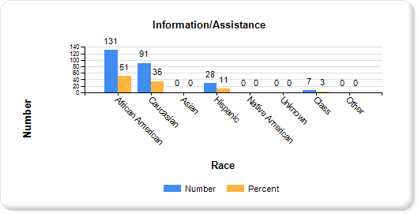
Chart 7C represents the total number of IA cases (257) reported by race. Of the 257 IA cases, 131 (51%)
were submitted by African American residents; 91 (35%) were submitted by Caucasian residents; 28 (11%) were submitted by Hispanic residents; and seven (3%) were class action cases, initiated by a group of patients not assigned to any specific race.

Chart 8: IA Cases by Gender, Age Group and Race – SETT Springfield
SEX | # | % | AGE | # | % | RACE | # | %
Male | 32 | 88 | <18 | 1 | 3 | African  American | 0 | 0
Female | 2 | 6 | 18-44 | 29 | 80 | Caucasian | 26 | 72
 |  |  | 45-64 | 4 | 11 | Asian | 6 | 16
 |  |  | 65+ | 0 | 0 | Hispanic | 0 | 0
 |  |  |  |  |  | Native American | 2 | 6
 |  |  |  |  |  | Other | 0 | 0
Class | 2 | 6 | Class | 2 | 6 | Class | 2 | 6
Total | 36 | 100 | Total | 36 | 100 | Total | 36 | 100
Chart 8: During FY 17, there were a total of 36 IA cases reported for SETT Springfield. There were two class action IA case, representing 6% of all IA cases reported for this facility.

The following set of graphs represent the total IA cases and respective percentages for SETT Springfield by gender, age group and race.

Cart 8A: IA Cases by Gender for SETT Springfield
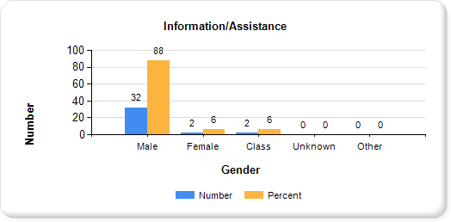
Chart 8A represent the total number of IA cases (36) reported by gender. Of the 36 cases, 32 (88%)
were submitted by male residents; two (6%) were submitted by female residents; and two (6%) were
class action IA cases, initiated by a group of patients not assigned to any specific gender.

Chart 8B: IA Cases by Age Group for SETT Springfield
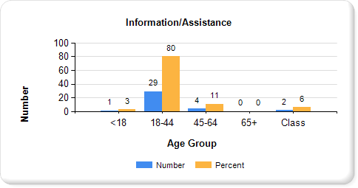
Chart 8B represents the total number of IA cases (36) reported by age group. Of the 36 IA
total cases, one (3%) was submitted by a resident < 18 years of age; 29 (80%) were
submitted by residents 18-44 years of age; four (11%) were submitted by residents 45-64
years of age; and two (6%) were class action IA cases, initiated by a group of residents not
assigned to any specific age group.

Chart 8C: IA Cases by Race for SETT Springfield
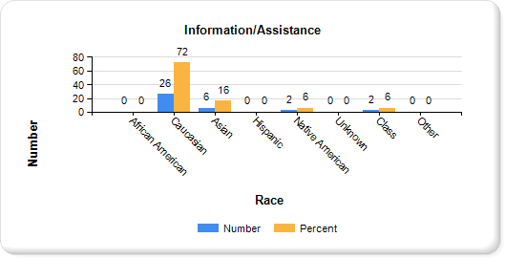
Chart 8C represents the total number of IA cases (36) reported by race. Of the 36 IA cases, 26 (72%) were submitted by Caucasian residents; six (16%) were submitted by Asian residents; two (6%) were submitted by Native American residents; and two (6%) were class action IA cases, initiated by a group of patients not assigned to any specific race.

RESIDENT GRIEVANCE SYSTEM

Rhonda Callum, Director
201 West Preston Street, Room 546

Baltimore, Maryland 21201
1-800-747-7454

Effective July 1, 2017, the Department of Health and Mental Hygiene was renamed to the Maryland Department of Health (MDH).
Effective July 1, 2014, the Mental Hygiene Administration and Alcohol and Drug Abuse Administration combined to become the Behavioral Health Administration (BHA).

